

MCTA 3300 SECTION 1 SEM 2 24/25
INTEGRATED DESIGN PROJECT

PROJECT REPORT :
AUTOMATIC WASTE SEGREGATION

Lecturer’s Name
DR. NOOR HAZRIN HANY BT MOHAMAD HANIF
DR. FARAHIYAH BINTI JASNI
Supervisors
DR. TANVEER SALEH DR. ASYRAF RAZIB
Group 5:
NO. | STUDENT’S NAME | MATRIC NUMBER
1. | Abdallah Mahamat Abacar Maeyd | 2117777
2. | Ahmad Zarady Bin Zulkefly | 2111837
3. | Almasri Suhail Jihad | 2128771
4. | Ibrahim Bin Nasrum | 2116467

TABLE OF CONTENTS
CHAPTER 1: INTRODUCTION 3
1.1. Background 3
1.2 Product Literature 4
1.3 Technical literature 7
1.4 Patent Literature 9
1.5 Customer Survey 11
1.6 Problem Statement 13
CHAPTER 2: CONCEPTUAL DESIGN 14
2.1 Objectives 14
2.2 Concept of the system 14
2.3 Engineering Characteristics 19
2.4 Quality of deployment - House of Quality ( HOQ ) 20
2.5 Product Design Specification 21
CHAPTER 3: SYSTEM DESIGN AND MODELING 23
3.1 Modeling of the system 23
3.1.1 Mechanical Subsystem 23
3.1.2 Electrical Subsystem 24
3.1.3 Circuit Diagram 27
3.1.4 Software and Algorithm 28
3.1.5 Machine Vision using Roboflow 32
3.2 Component Design 35
3.2.1 System Drawing 38
3.3 Design of Manufacture ( DFM ) 45
3.4 Design of Assembly ( DFA ) 46
3.5 Costing 47
3.6 Discussion on Safety, Environment, Social Impact and Sustainability Product 48
CHAPTER 4: MARKETING AND BUSINESS MODEL 51
4.1 Scaling Up and Marketing the Product 51
4.2 Break-Even Analysis 52
4.3 Summary 53
CHAPTER 5 : CONCLUSION 54

CHAPTER 1: INTRODUCTION

1.1. Background

The problem of waste management has consequently grown to be a global issue due to the ever-increasing population and increased rate of urbanization resulting in the production of an enormous amount of waste from households, industries, and institutions daily. Manual sorting of wastes is ineffective, time-wasting, cost- and labor–intensive and consequently; it is associated with high levels of imprecision and inaccuracies. It is why traditional approaches to handling wastes are becoming less useful when novel solutions to the impacts of environmental sustainability are desperately needed.

Automatic waste segregation systems are features that are far improvements to waste management. These systems employ advanced features of technology including AI, robots, and machine learning to sort through the items hence greatly lessening their reliance on humans and the consequential mistakes. Adopting these technologies in segregation of wastes assist in increasing the capacity for sorting when properly applied to the waste management process hence increasing the overall efficiency in the recycling process.

Some remarkable solutions have appeared in the past few years; this information proves the effectiveness of automated waste segregation systems. These include ZenRobotics Recycler that employs robotic arms controlled by artificial intelligence to sort construction and demolition waste to very high accuracy and in real time. The technology of computer vision and machine learning is used in AMP Robotics for sorting and recycling of recyclables and includes different materials including plastic, paper, and metals. Companies such as Sadako Technologies realized the concept of robotics by creating state-of-art robots to pick and sort waste at massive speed and great accuracy, hence transforming the effectiveness of waste management.

The use of such sophisticated technologies in waste management is informed by the increase in environmental problems relating to the improper disposal of wastes and the depletion of natural resources. Promisingly, such capabilities boost recycling and cut the use of landfills and discharge of redundant greenhouse gases into the environment as a result of efficient segregation systems. It allows the recycling of useful materials from waste flows which in turn fosters the concepts of circular economy hence enhanced sustainability.

It can be understood that incorporating the instances of the automated waste segregation systems into the existing waste management frameworks is not only advantageous but mandatory as the world progresses further towards sustainability. Such systems provide a plausible solution to the difficulties caused by approaches to waste segregation, providing the grounds for a new age in the improvement of waste management procedures. As AI, robotics, and machine learning continue to evolve, it will present more opportunities for stretching the field further and coming up with efficient ways of improving the effectiveness and sustainability of the segregation of wastes.

1.2 Product Literature

Automated methods of waste disposal have been developed in recent years and several products have been designed to work through mechanisms of automated waste segregation with certain characteristics. These products include AI, robotics, machine learning among others to improve the speed and effectiveness of sorting out the wastes. Besides, the usage of these technologies in the formation of the products serves to minimize time and effort while enhancing the efficiency of environmental control.

This section provides an overview of three prominent solutions: such as the ZenRobotics Recycler, AMP Robotics, and Sadako Technologies. All these products are individual masterpieces aimed at responding to definite difficulties of waste segregation and adapted to provide the highest possible level of differing features in waste management. Further down each of these products is described in terms of its dimensions, weight, sorting capability, power consumption, as well as the run time.

ZenRobotics Recycler

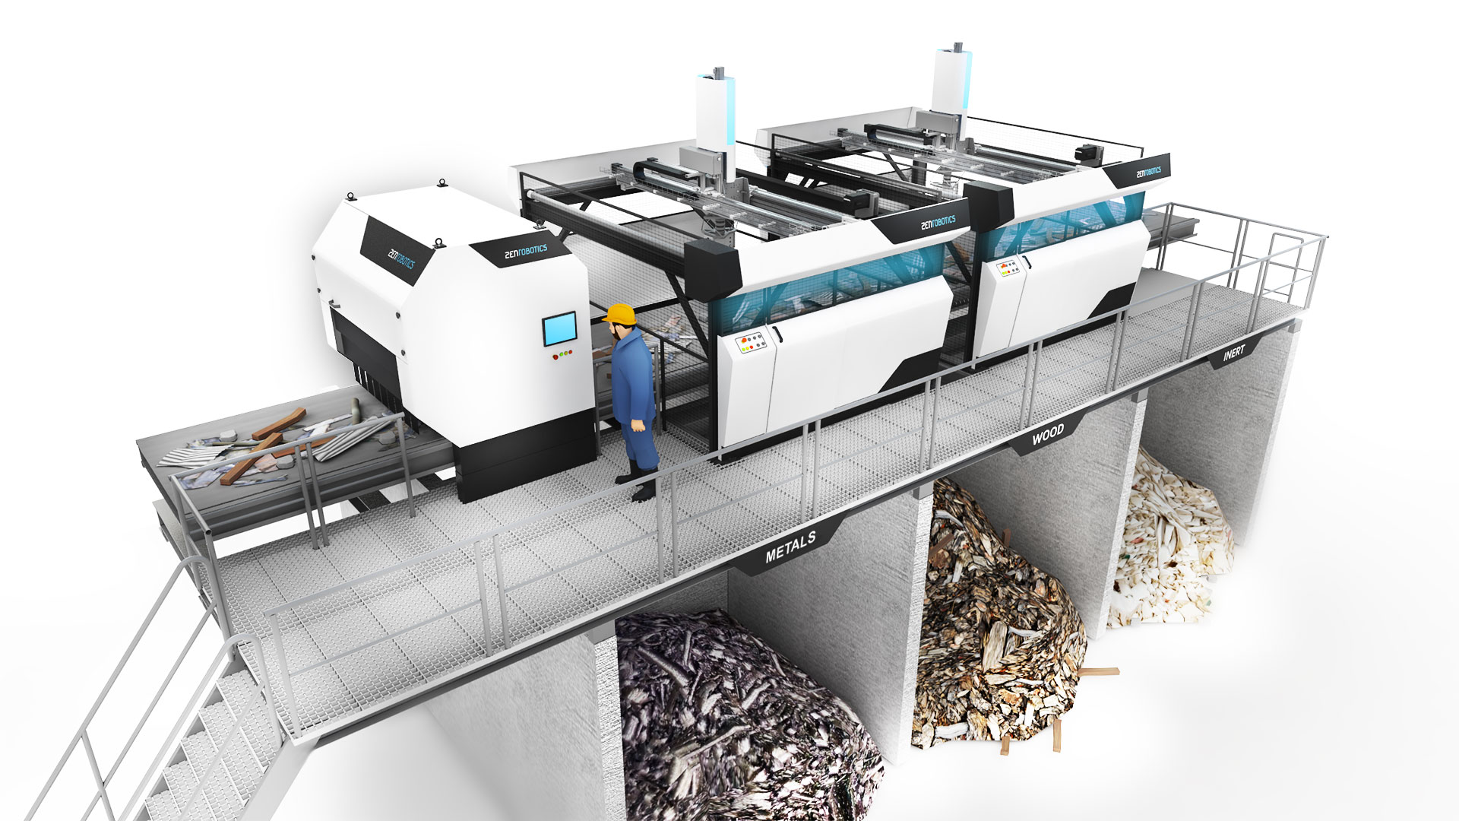
Dimension | 2000 x 3000 x 2500 mm
Weight | 800 kg
Sorting Capacity | 50 tons per hour
Power Consumption | 15 kW
Run Time | Continuous operation with regular maintenance

ZenRobotics Recycler is a cutting-edge robotic waste sorting, which helps to sort construction and demolition waste with the help of AI-controlling robotic arms. This system is generic to accommodate different types of materials; this makes it easier to sort the material with a high degree of accuracy and considerably minimises the amount of work done by hand. And it runs with monitoring and analyzing in real-time and is easily diagnosable when there is a problem with performance.

AMP Robotics

Dimension | 1800 x 2500 x 2200 mm
Weight | 650 kg
Sorting Capacity | 40 tons per hour
Power Consumption | 12 kW
Run Time | Continuous operation with regular maintenance
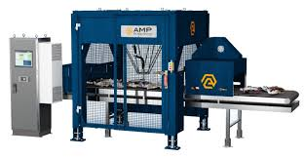

Specifically, AMP Robotics utilizes computer vision and AI to identify, sort, and recycle some elements of items such as containers, cans, and bottles. Due to the versatility of the system, it can accept a variety of materials; for instance, plastics, papers and metals among others. In its operation, AMP Robotics can keep on enhancing its sorting capacities, thus, regarding its leading position in waste management solutions, it can learn and adapt.

Sadako Technologies
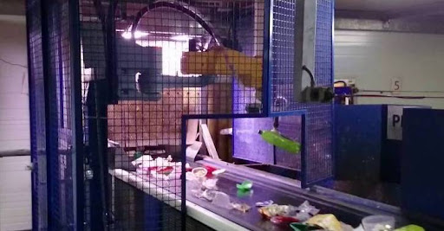

Dimension | 1600 x 2300 x 2100 mm
Weight | 600 kg
Sorting Capacity | 35 tons per hour
Power Consumption | 10 kW
Run Time | Continuous operation with regular maintenance

Currently, Sadako Technologies have designed robots with artificial intelligence sense that enables the robots to pick and sort the waste materials with immense efficiency and precision. They play a major role of improving on the efficiency of waste management and save a lot of time and efforts that would otherwise be required in sorting of wastes and boosting the throughputs in recycling processes. This is a good addition to any waste management facility since the operations of the system are very fast and accurate.

1.3 Technical literature

To enable the Automatic Component Segregator, it is first necessary to use a smart transistor testing kit that cuts and reassembles parts of the circuit. Technical literature is the paperwork that contains the detailed information of the product, the design, the work and the care. This can include general guides and instructions currently popular among users, installation manuals, descriptions of the technical characteristics of the product, instructions in case of the product’s malfunction, and safety standards. Technical literature is employed to inform the user about the capabilities and liabilities of the product as well as presenting to the user the information required to correctly install, set up and maintain the product.

Automatic Component Segregator Enabled with a Smart Transistor Testing Kit

The name ACE with STTK refers to another creative invention of the researchers that is an apparatus intended for the automatic segregation of the functional and non-functional components from the waste PCBs with an insignificant amount of human interference. Described by Nitin et al. and published electronically on June 16, 2017, the patent named ‘Sorting and function check method for e-waste and apparatus thereof’ (TW 201720535 A), the invention is characterized by multiple functional sorting stages.

Product Design and Function: Mechanical, electrical, and software components that are interrelated make up the apparatus with a view of accomplishing its functions. The waste PCBs are first introduced into the system for a primary classification aimed at excluding large elements. After this, a smart transistor testing kit checks the statute of individual components. Complex components are arranged for possible reuse, and simple ones are gathered for recycling or for being disposed of. It has been designed in such a manner that there will be lesser use of manpower and at the same time the efficiency of the recovery rate of the material will be very high.

Safety Information: Precautions that are required in order to give safe operations are called for by the specific use of the device. It must operate in a contained environment so as not to expose workers and others to the dangers that come with e-waste. Personal protective equipment like gloves and safety goggles should be worn by the operators to avoid cases of cut or exposure to chemicals. It is very important for the system to be checked at some set intervals, so the current state of the equipment used can be identified and possible dangers from these flaws avoided.

Error alerts from the transistor testing kit indicate issues with component functionality tests; users should recheck the positioning and connectivity of the PCBs within the system.
Technical Specifications: Dimensions: 2000 x 3000 x 2500 mm Weight: 800 kg Sorting Capacity: 50 tons per hour Power Consumption: 15 kW Run Time: Continuous operation with regular maintenance Environmental Protection: Given the presence of hazardous materials in e-waste, proper disposal and recycling are crucial. Operators should follow local regulations and guidelines for disposing of non-functional components and materials that cannot be recycled.

1.4 Patent Literature

2.3.1 Device for waste segregation and collection of segregated waste
Author : Marcin et al.
Published : 15 July 2021
Patent Number : US 2021/0214154 A1

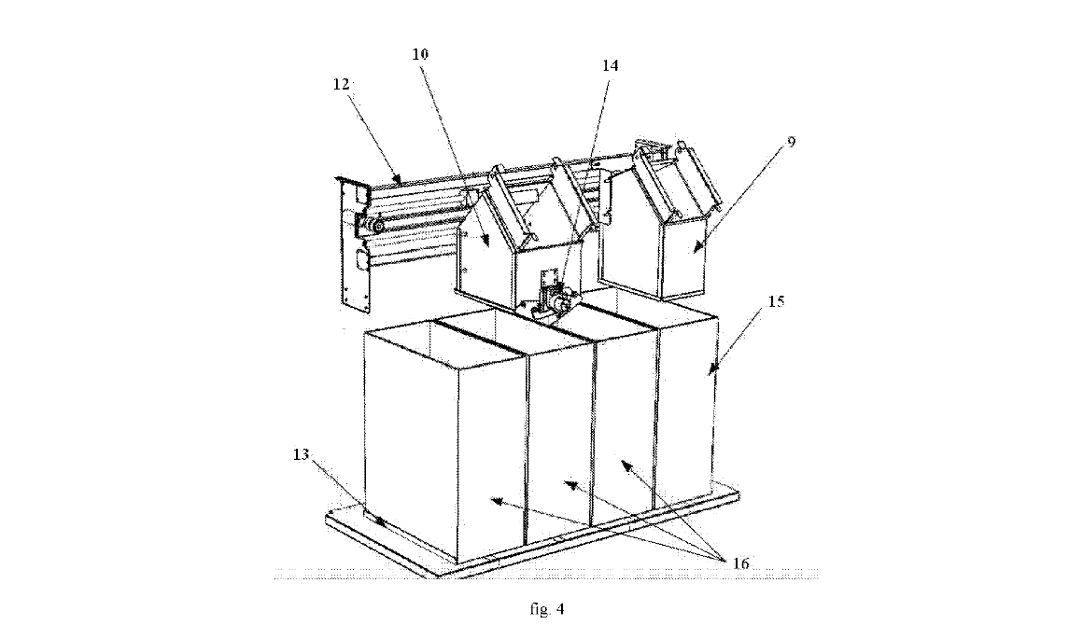
This patent consists of a device for waste segregation and collection of segregated waste, featuring a waste recognition, segregation, and distribution section, a compression mechanism, and storage bins. It is distinguished by the storage bins (15)(16), which have fill level sensors and are inserted into the guideways of the base (13). Directly over one of the side storage bins (15), there is a throwing box attached to the casing, with a throwing tunnel (9) and a lid with a sensor that detects whether the lid is open or closed (4). Above the bins (16), on a system of horizontal guideways (12) attached to the casing, there is a distribution cart (10) that moves sideways on the guideways, powered by a gear motor controlled by a control system. The distribution cart (10) includes a throwing mechanism (14) with at least one automatic throwing lid (11). The distribution cart operates with its own throwing box, which also has a lid with a sensor that detects whether it is closed or open (6). Within the throwing channel of this throwing box (6), there is a sensor of the waste recognition system—a camera.

2.3.2 Automatic component segregator enabled with a smart transistor testing kit(s)
Author : Nitin et al.
Published : 16 June 2017
Patent Number : TW 201720535 A
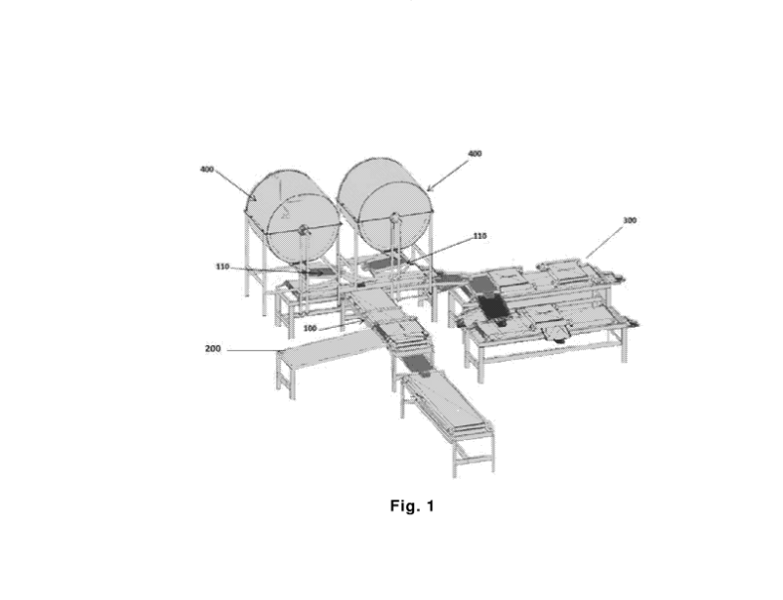
The present invention pertains to an apparatus designed for the automatic segregation of functional and non-functional components from waste printed circuit boards or electronic waste with minimal or no manual intervention. The apparatus includes a component segregation section and a functionality check section, which is equipped with at least one transistor testing kit to distinguish between functional and non-functional transistors at various stages based on their functionality, nature, and reusability. The components from the waste product are then separated through multiple stages, involving steps such as shredding, size sorting, metal sorting, and the sorting of reusable parts such as chips, transistors, resistors, etc. In the functionality check section, the extracted transistors undergo a physical integrity inspection followed by a conductivity test. If a transistor passes both the physical integrity and conductivity tests, it is deemed suitable for reuse. Otherwise, it is directed to mechanical recycling.

1.5 Customer Survey

In the context of product development, customer satisfaction is paramount, as customer preferences and feedback significantly influence design choices and enhancements. To ensure that our automated waste segregation system meets the specific needs and expectations of its users, we conducted a comprehensive customer survey targeting a broad audience, including IIUM students, residents, and various other stakeholders. This survey aimed to gather direct insights from the target audience regarding their attitudes, knowledge, and behaviors toward waste management and segregation.

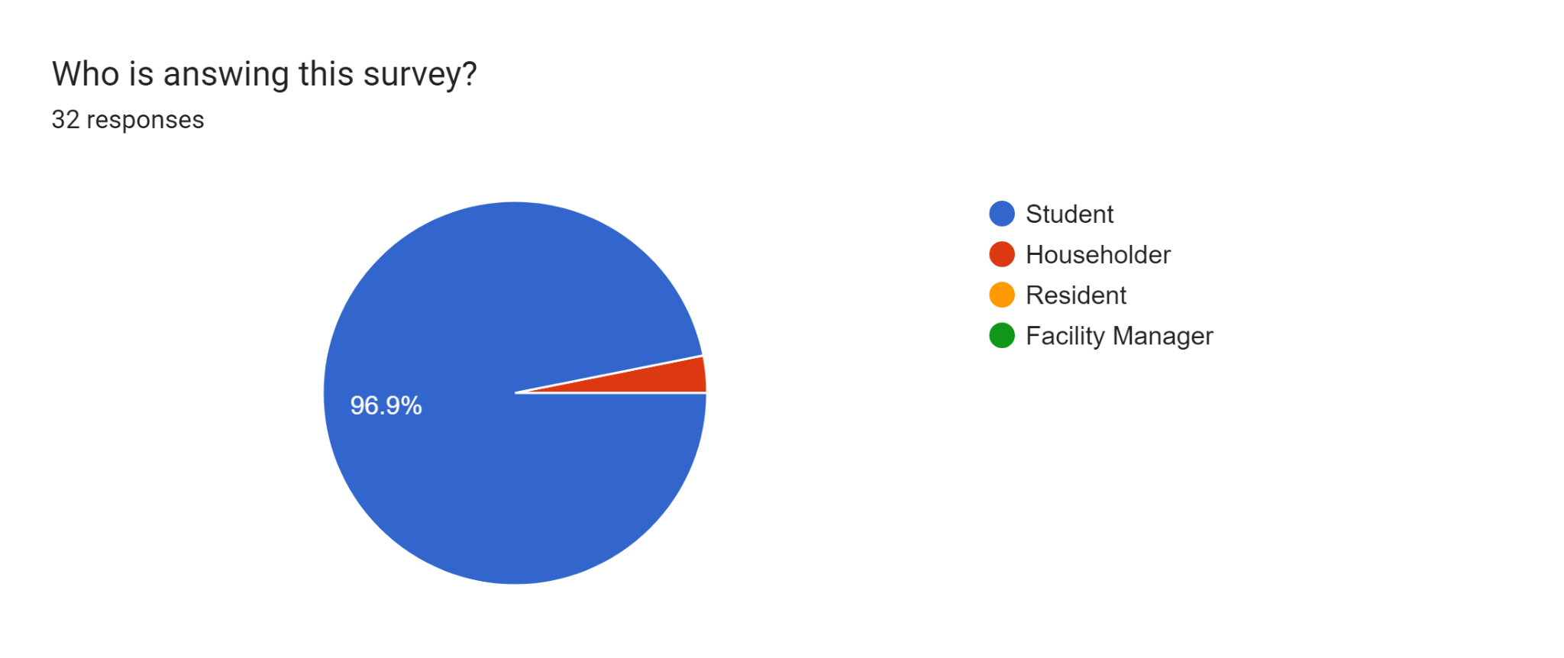 | 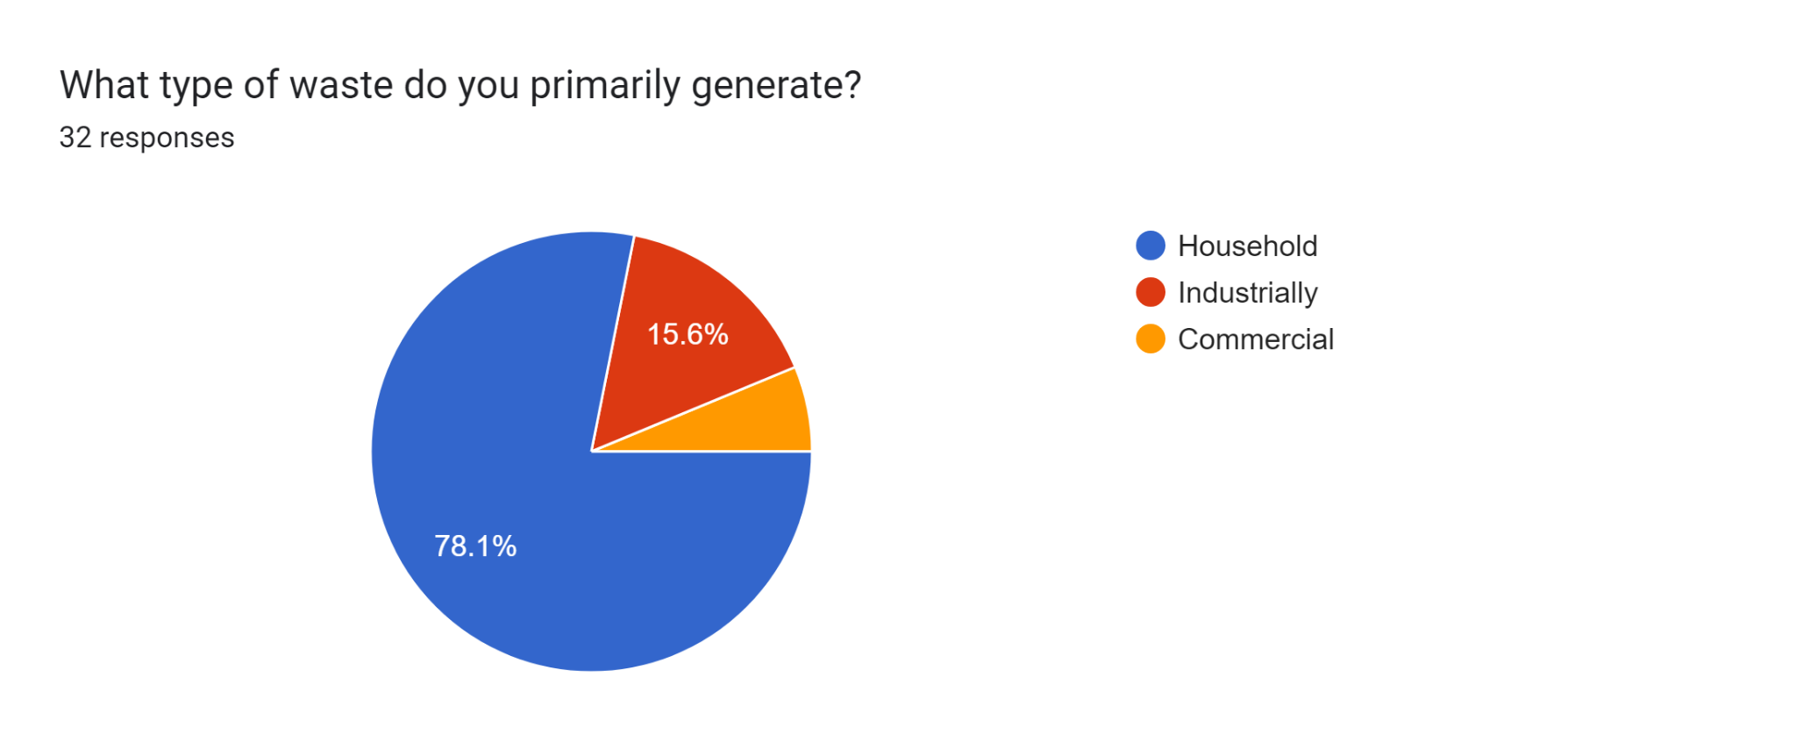
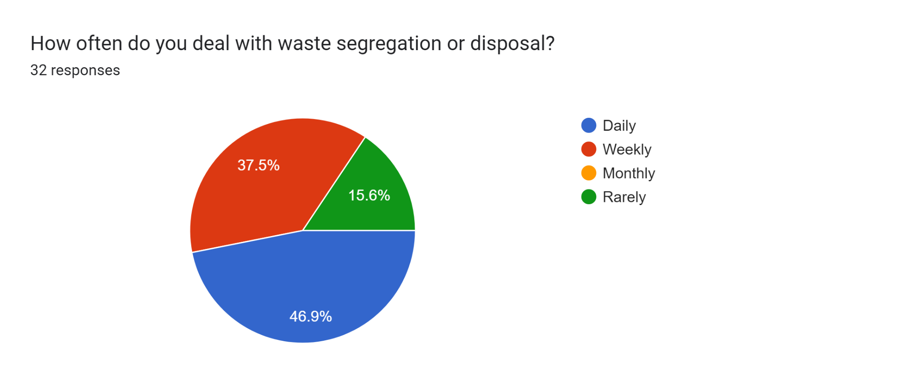 | 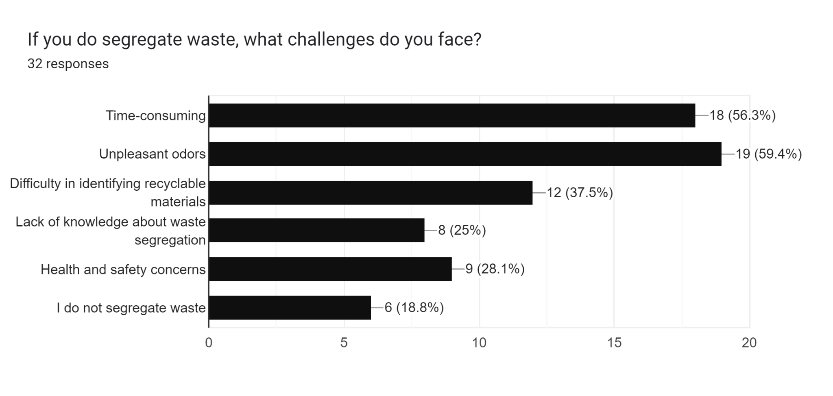
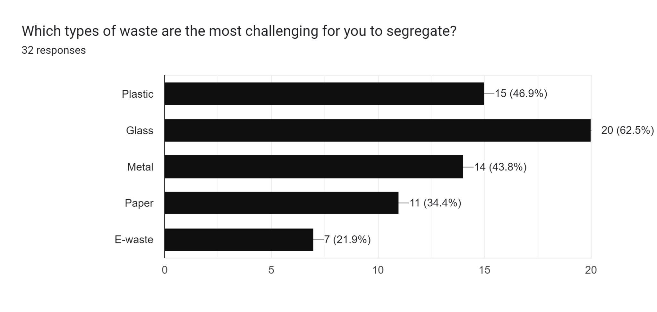 | 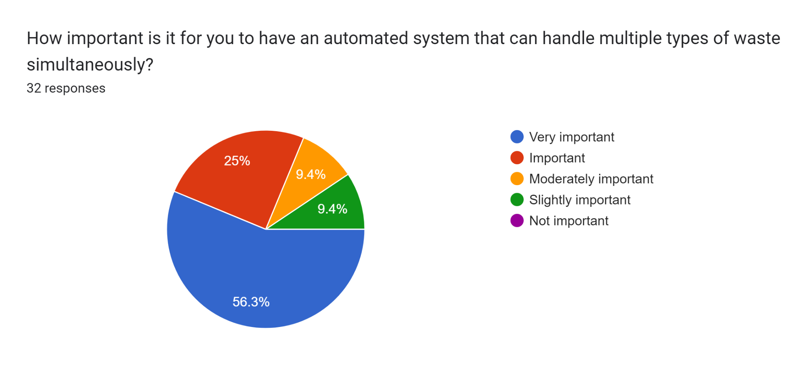
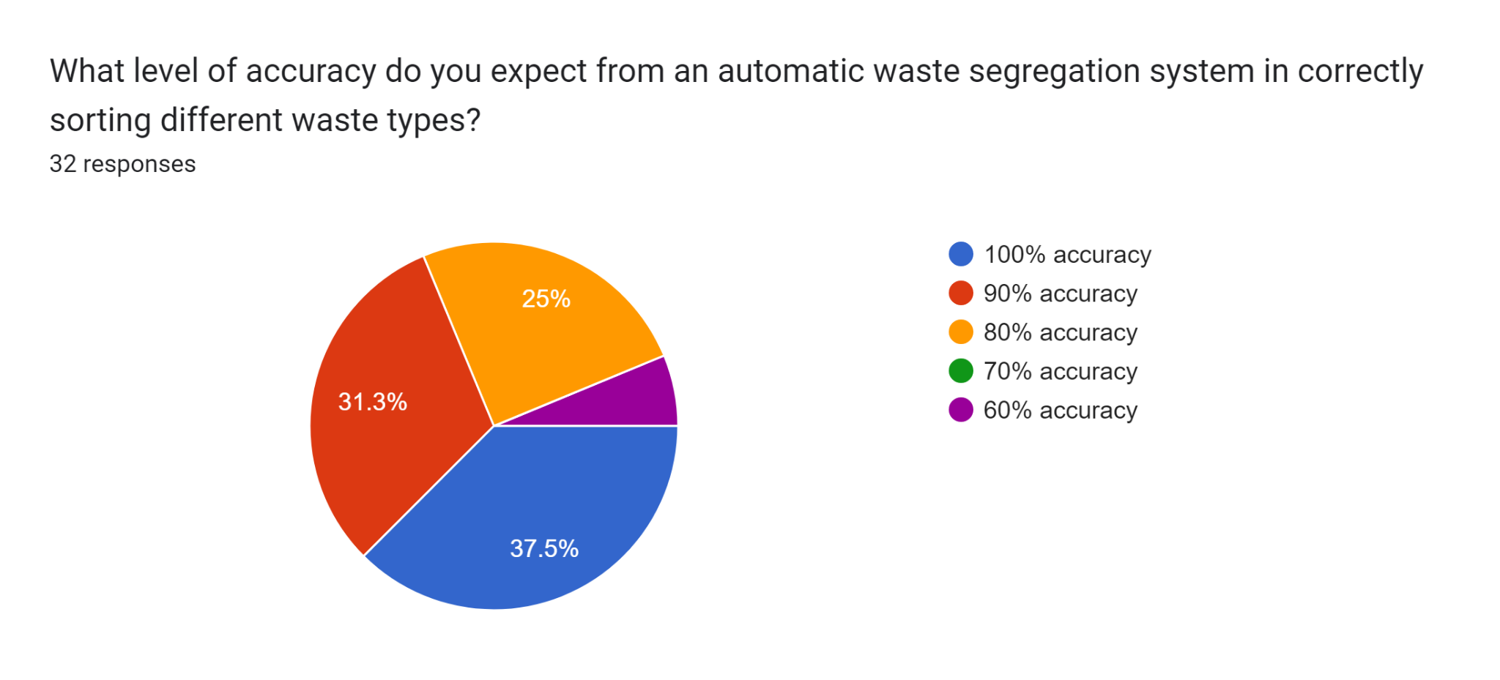 | 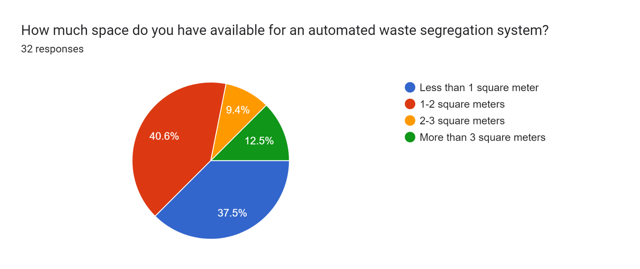
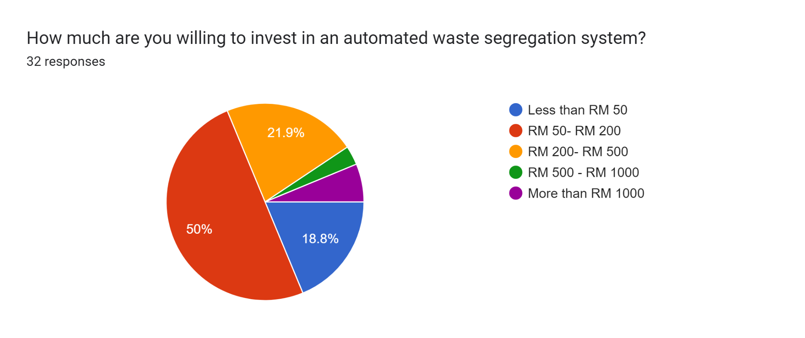 | 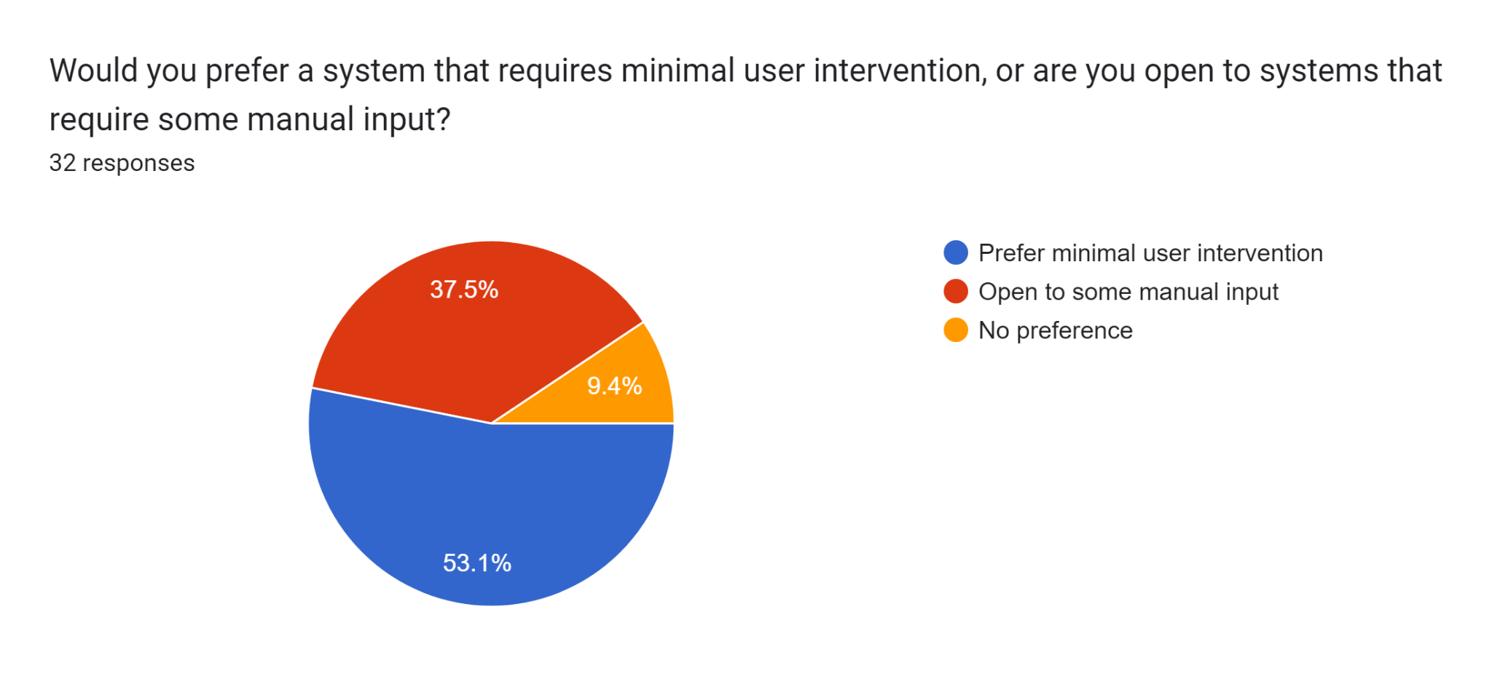
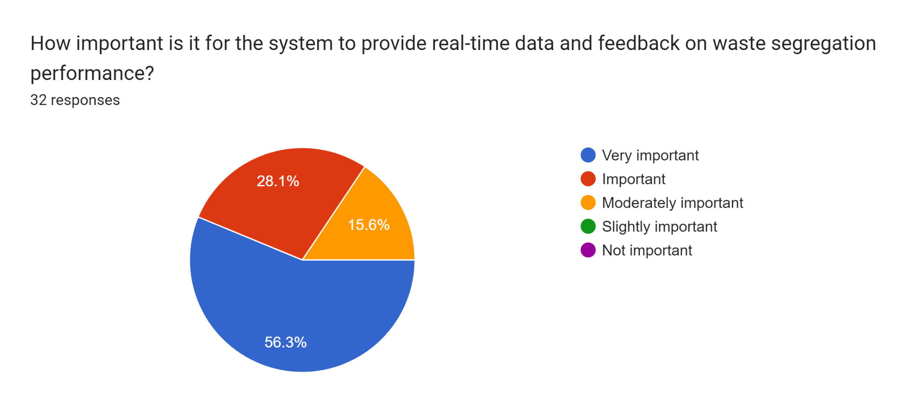 | 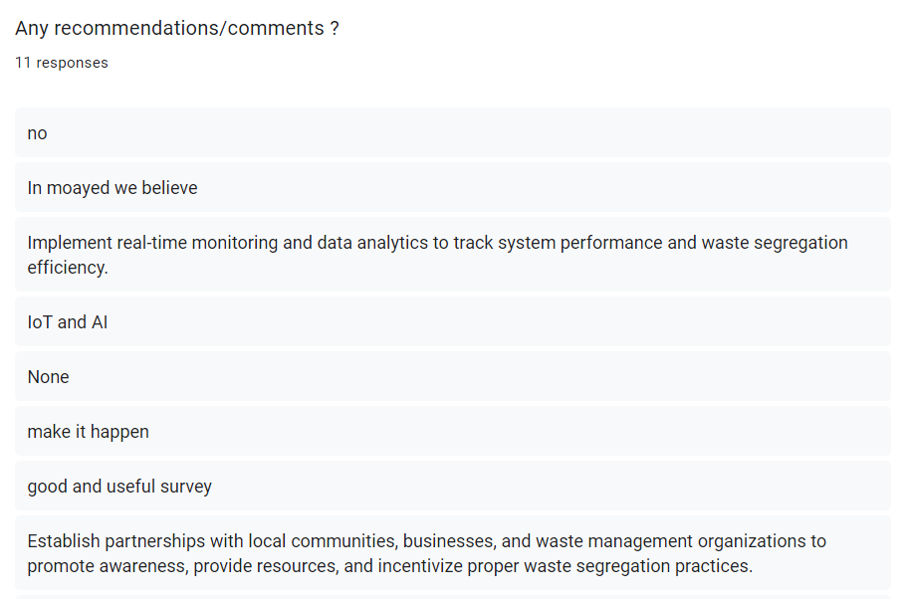

The survey was distributed through various digital channels, including WhatsApp, Telegram, and social media platforms, utilizing Google Forms to facilitate easy and accessible participation. A total of 32 people participated in the survey, providing valuable data that helps us understand the critical aspects and features desired in an automated waste segregation system. The gathered responses offer a detailed view of the current challenges faced in waste management, the importance placed on different system attributes, and the preferences related to accuracy, intervention, and budget.
Most of the people who answered this survey are students which has a percentage of 91.6 percent. The average of these people deal with waste segregation or disposal daily and most of these people dispose of the waste in their household. Unpleasant odors are the biggest challenges faced by people while glass is the most challenging type of waste when dealing with waste segregation. 56.3 percent of people feel that it is very important to have an automated system that can handle multiple types of waste simultaneously. Average of the person would like to have an automatic waste segregation system that has 100% accuracy, a space of 1-2 m, and also prefers to have minimal user intervention. Lastly, the average of people are willing to invest at least RM 50- RM 200 for this automatic waste segregation machine.

1.6 Problem Statement

Public places need an efficient and effective way to manage and segregate waste because improper waste segregation in high-traffic areas leads to increased environmental pollution, decreased recycling efficiency, and higher waste management costs. Manual sorting of waste in public spaces is often labour-intensive, prone to errors, and can be unhygienic for workers. An automated waste segregation system designed for public use can address these issues by accurately sorting recyclable materials like metals, plastics, glass, and paper, thereby promoting sustainable waste management practices and reducing the operational burden on public maintenance services.

CHAPTER 2: CONCEPTUAL DESIGN

2.1 Objectives

The objectives of this project are :

- To design a machine that can segregate recycled waste (Paper, glass, plastic, and metal) to minimize the manual sorting efforts.
- To evaluate the performance of the machine

2.2 Concept of the system

After conducting research to find a suitable solution to the problem outlined in the problem statement, our group developed three proposed combination designs based on a few designs. First of all, The design of the automatic waste segregation system is structured into three distinct areas: Area A (the head), Area B (the body), and Area C (the bottom). Each area serves a specific function within the system.

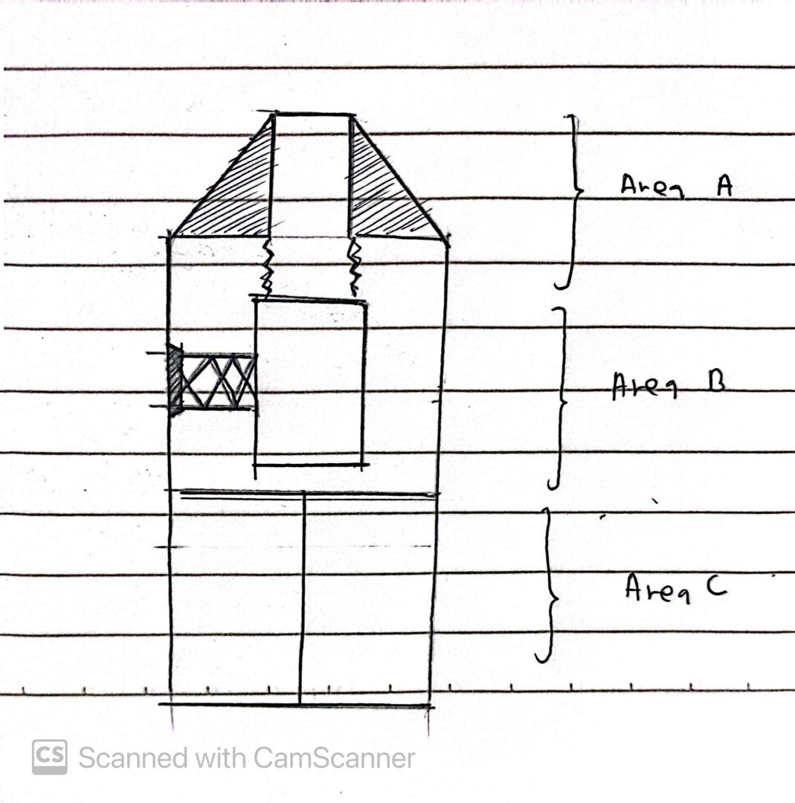
Concept Image 1.0

Area A (the head) : This section acts as the entry point of the bin, functioning as a collector for incoming waste. It is designed to facilitate the initial collection of materials.

Briefly explanation about designs for Area A ;
Design A1 : Manual push lid
Design A2 : Manual pull lid
Design A3 : Automatic open lid by pressing touch sensor and square shape
Design A4 : Automatic open lid by pressing touch sensor and circle shape
Design A5 : Open lid
Design A6 : Open lid and pyramid shape

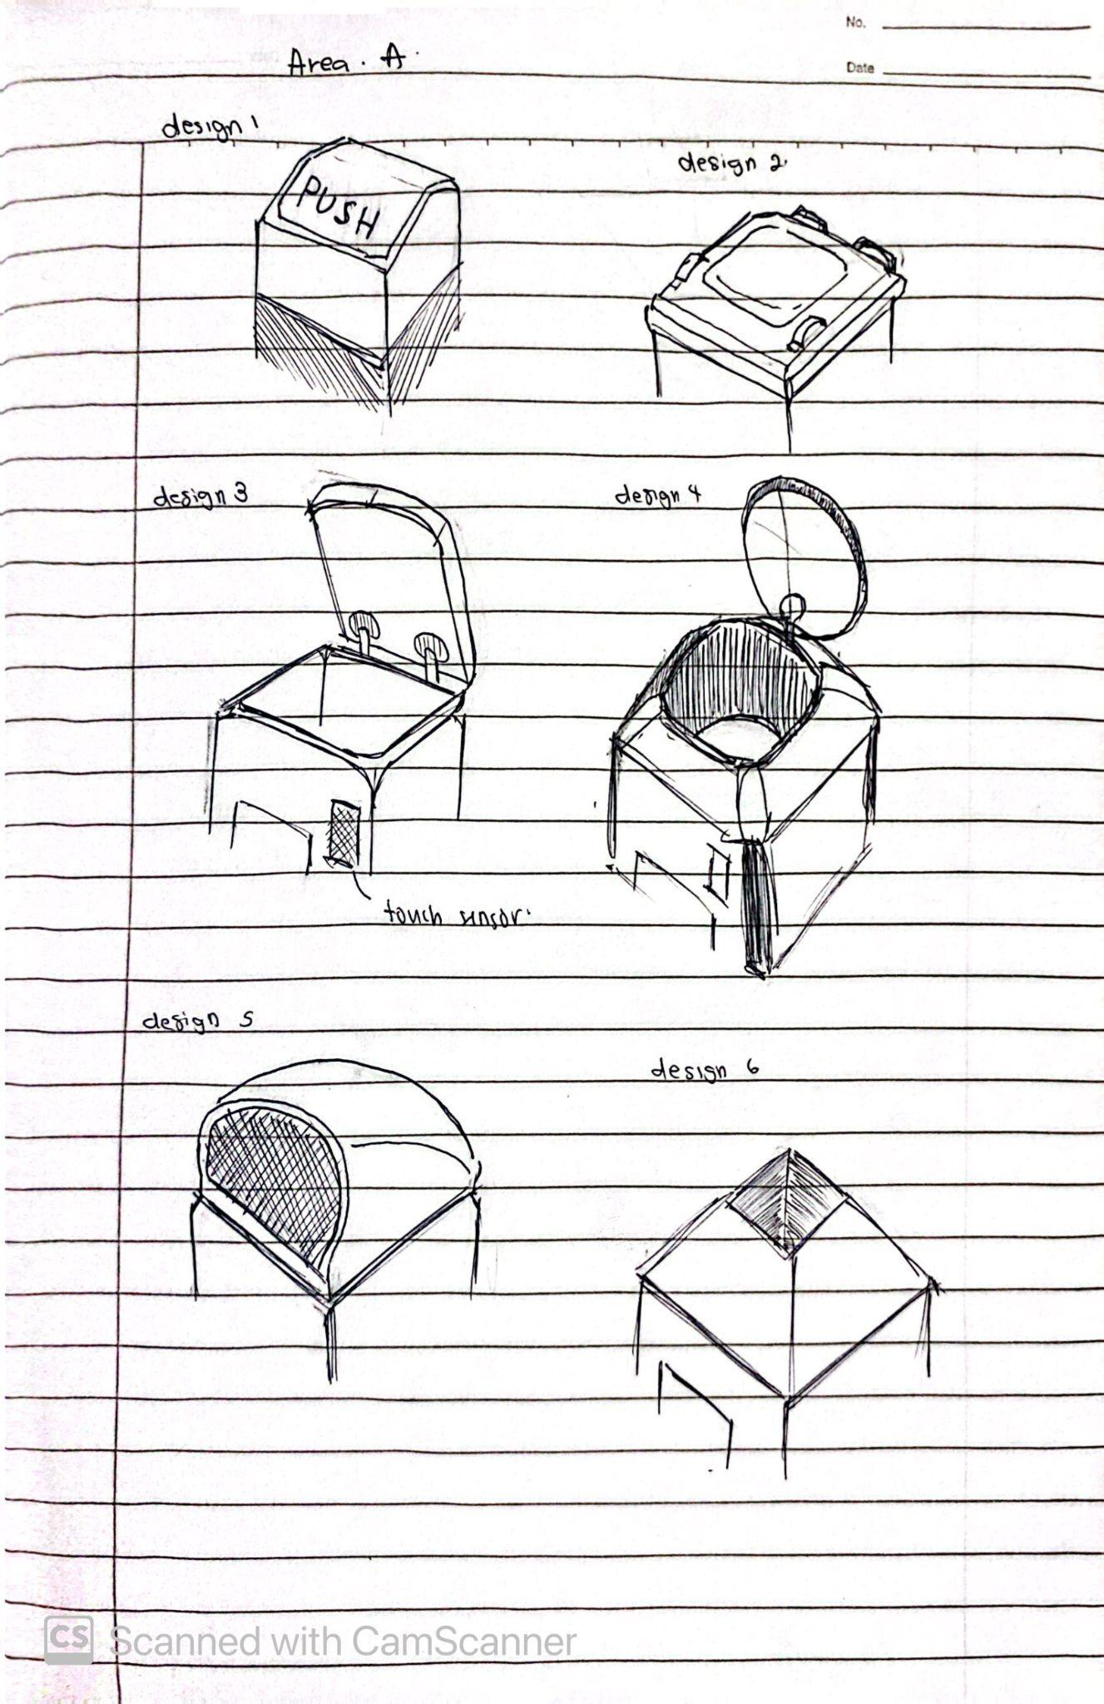

Concept Image 1.1

Area B (the body): This section is dedicated to the detection and sorting of waste in a cylinder. Equipped with a camera and AI technology, Area B accurately recognizes and categorizes the materials. This sorting mechanism ensures that each type of waste is correctly identified.

Briefly explanation about designs for Area B ;
Design B1 : There will be a huge bearing at the bottom of Area B for a rotation and attached with a servo motor to control ( open and close ) a piece of metal ( circle shape ) at the bottom of Area B. After the inspection, it will rotate to align with its compartment , then the servo will activate.
Design B2 : The concept is the same as a 3d printer, it can move in a direction of x and y axis. After the inspection, it will move linearly to its compartment and the servo will activate.
Design B3 : The cylinder is not moving (fixed position).

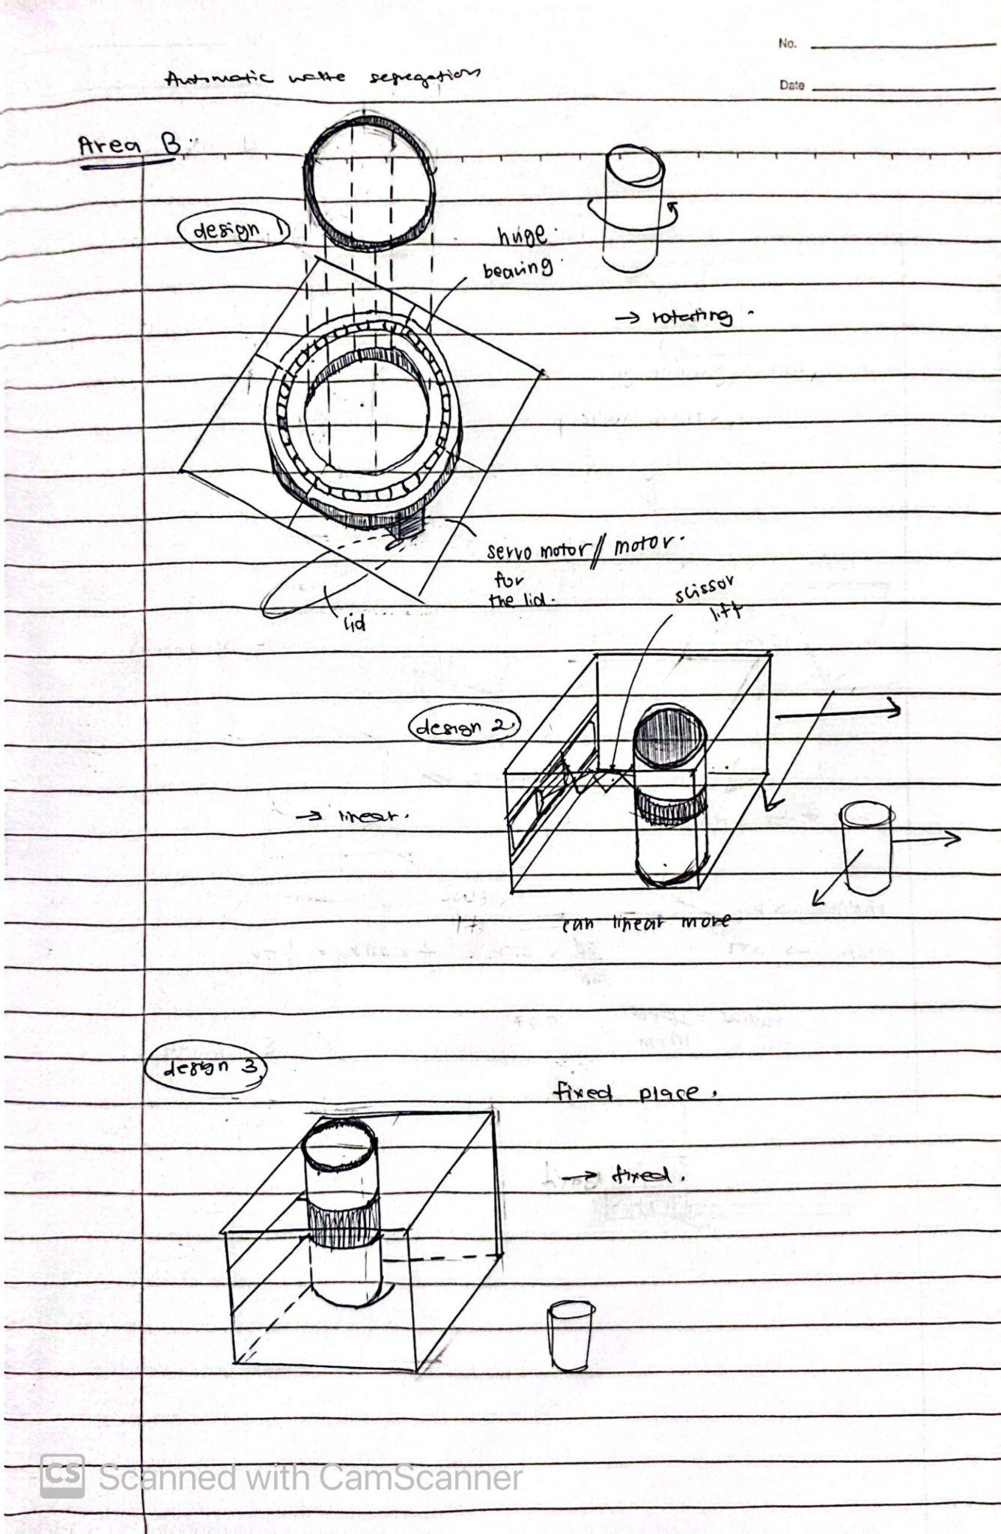

Concept image 1.2

Area C (the bottom): This section serves as the storage compartment for the sorted materials. It consists of four distinct compartments designated for metal, plastic, glass, and paper. This organisation allows for efficient separation and storage of recyclable waste.

Briefly explanation about designs for Area C ;
Design C1 : In this design, this part rotates accordingly, it will use a bearing and motor at the bottom of Area C.
Design C2 : The compartment is not moving ( fixed position ).

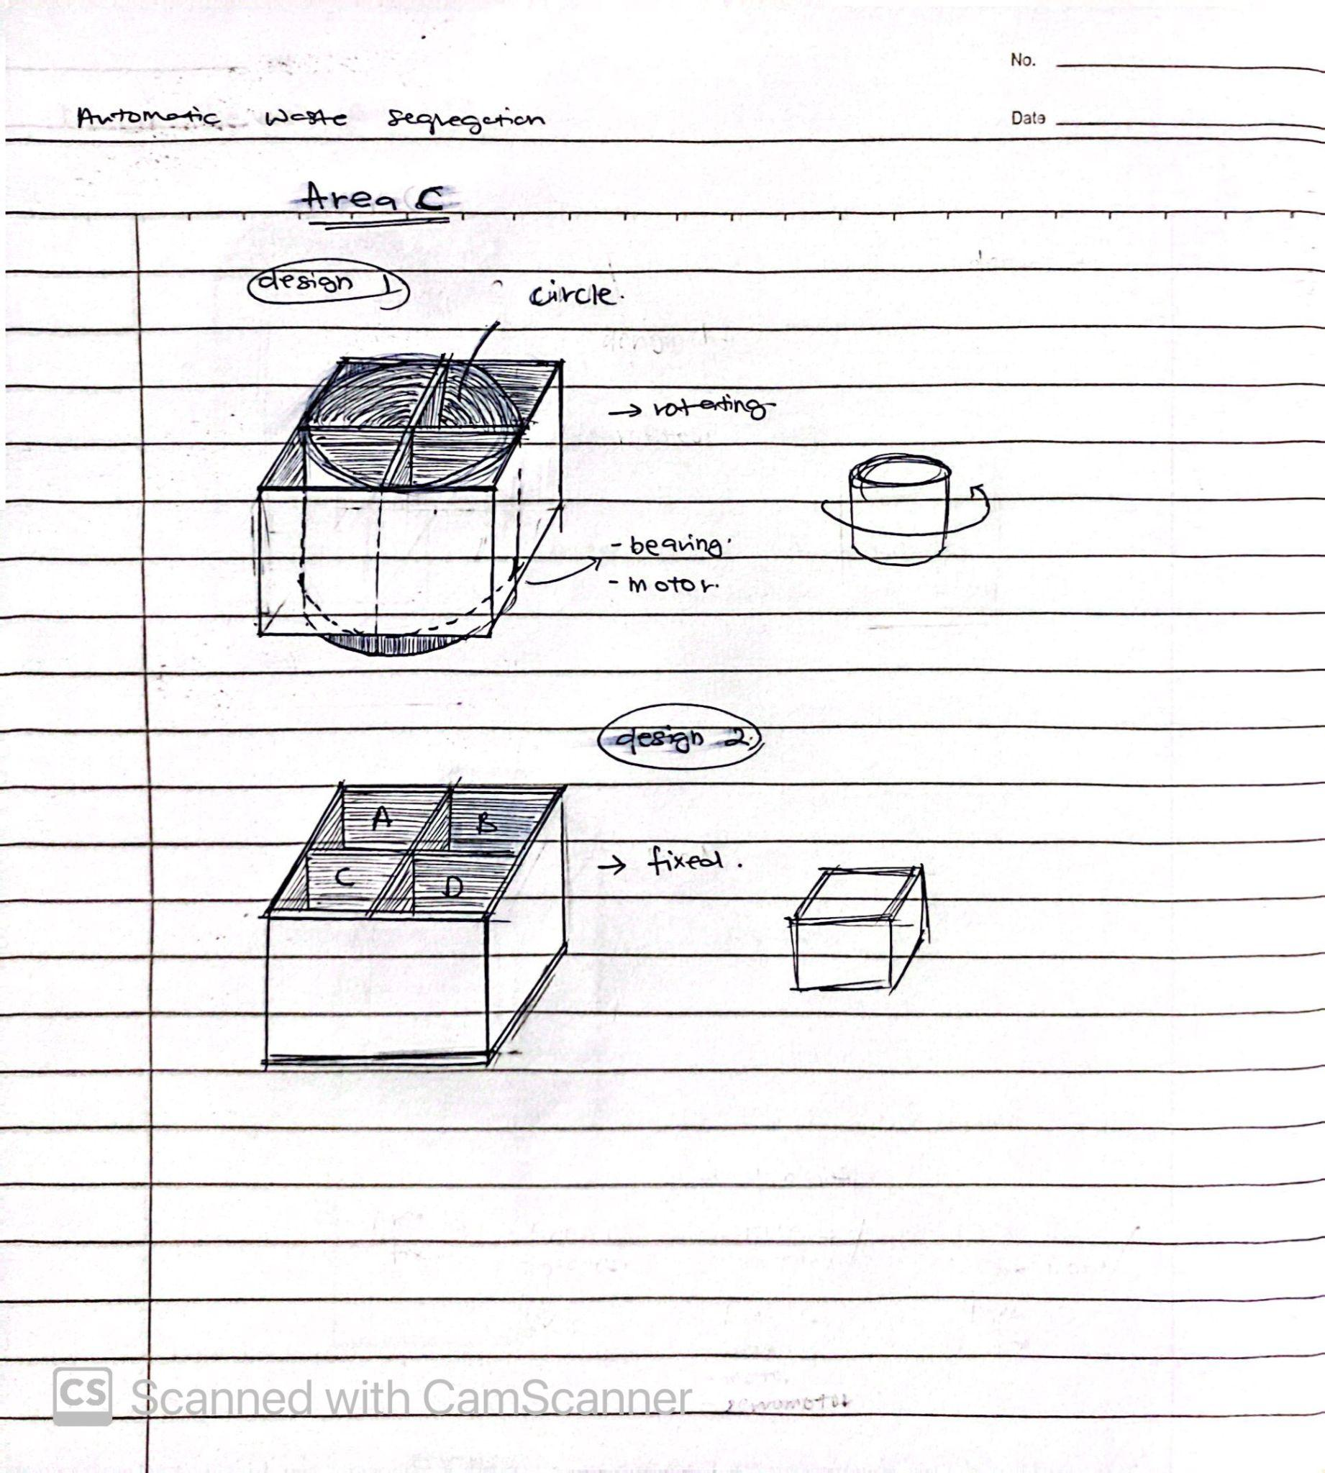

Concept image 1.3

After brainstorming various ideas, we proposed several combinations of designs for Areas A, B, and C. The proposed combinations are as follows:
First Combination (Design 1 ) :
- Area B: Design 2 (linear movement mechanism similar to a 3D printer)
- Area C: Design 2 (fixed compartments)
Second Combination (Design 2 ):
- Area B: Design 3 (fixed cylinder)
- Area C: Design 1 (rotating compartments with bearing and motor)
Third Combination (Design 3 ):
- Area B: Design 1 (rotating mechanism with servo motor)
- Area C: Design 2 (fixed compartments)
After further evaluation, we decided to select the best design using the Pugh Chart method. In this method, each design is compared to a reference design (Design 2) based on specific crucial criteria.

2.2.1 Pugh Chart

Selection Criteria | Concepts
 | Design 2 | Design 1 | Design 3
Cost | DATUM | S | -
Ease of operation |  | + | S
Speed of operation |  | + | S
Does not Jammed |  | S | S
Consumption energy |  | S | S
Weatherproof |  | S | S
Dimension |  | S | S
Sensor Accuracy |  | S | S
Weight |  | + | +
Durability |  | S | S
Safety |  | S | S
Reliability |  | + | +
Sum (+) |  | 4 | 2
Sum (-) |  | 0 | 1
Sum |  | 4 | 1

The Pugh Chart above clearly demonstrates that Design 1 is the optimal choice, as it has the highest number of positive evaluations.

2.3 Engineering Characteristics

No | Engineering characteristics | Unit | Improvement Direction | Explanation
1 | Jamming probability | % | ↓ | A low jamming probability keeps the system running smoothly and minimizes downtime for maintenance.
2 | Time to run the machine | s | ↓ | This should be as short as possible to improve efficiency.
3 | Sensor accuracy | n/a | ↑ | This should be high to ensure that waste is sorted correctly.
4 | Complexity of the system | n/a | ↓ | This should be relatively low to make the system easier to maintain and repair.
5 | Material Rigidity | Mpa | ↑ | the materials used should be strong enough to withstand the weight and impact of waste items.
6 | Weight | kg | ↓ | This should be minimized to reduce costs and improve portability.
7 | Size | m^2 | ↓ | A smaller system will be more affordable and easier to move
8 | Material toughness | Mpa | ↑ | The materials used in your system should be tough enough to withstand wear and tear.
9 | Weather resistance | n/a | ↑ | If the system will be used outdoors, the materials used should be weather-resistant.

2.4 Quality of deployment - House of Quality ( HOQ )

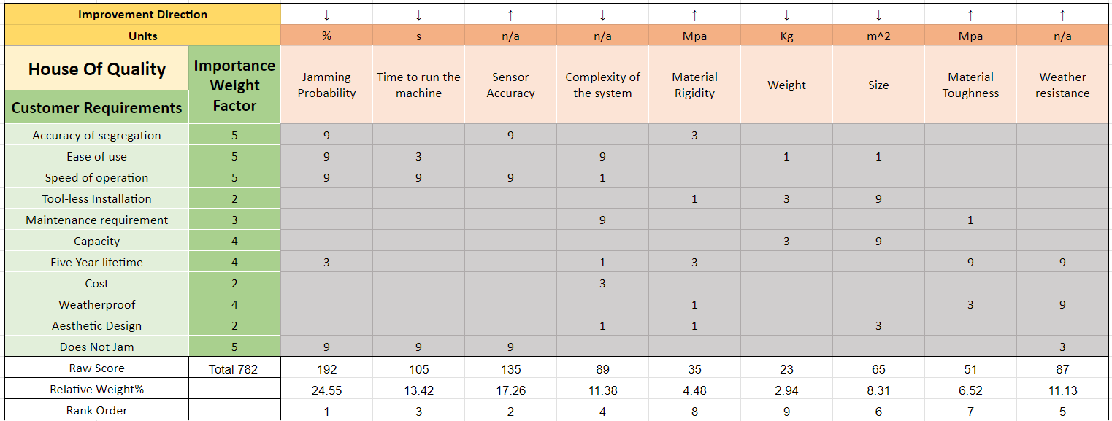

Based on the figure above, the House of Quality (HOQ) clearly ranks the engineering characteristics according to customer requirements. By analyzing the HOQ, we can identify and prioritize what our customers expect from our product. It is found that the probability of jamming is the primary concern for our future customers. Lowering the jamming probability will ensure a higher degree of reliability in our product. This is followed by sensor accuracy, which is ranked second and is crucial due to its strong connection to the safety features of our product. The time required to run the machine ranks third, highlighting its importance as the machine needs to be portable.

2.5 Product Design Specification
2.5.1 Product Overview
- Name: Automated Waste Segregation System
- Function: To automatically segregate household and commercial waste into categories such as metal, plastic, paper and glass, enhancing recycling efficiency and reducing the need for manual sorting.
- Dimensions:
  - 600mm x 600mm x 1000mm
- Material: Durable steel and high-quality plastic
2.5.2 System Components
- Waste Identification System
The Waste Identification System employs cutting-edge sensors such as optical, infrared, and inductive sensors, coupled with AI algorithms, to precisely categorize various types of waste. It achieves a minimum accuracy of 90% in waste identification, ensuring efficient sorting processes. Regular calibration and sensor cleaning are essential maintenance tasks to uphold accuracy over time, ensuring reliable performance in waste segregation operations.
- Sorting Mechanism
The Automated Waste Segregation System features a mechanical setup with a linear motion of a waste sorting mechanism to automatically separate waste into specific bins. It efficiently handles up to 5 kg of mixed waste in just 10 minutes. Built from durable, low-maintenance materials, the system ensures reliability and longevity in waste management operations.

- Security Features
The system incorporates safety features such as sensors to prevent accidents and unauthorized access. An easily accessible emergency stop button is also provided to swiftly halt operations in critical situations, ensuring user safety and system integrity.
- Notification System
The notification system provides real-time alerts to users via a GSM module, notifying them of important events such as system errors, maintenance requirements, and full waste bins. Additionally, it enables remote monitoring and control through a dedicated mobile app, enhancing operational efficiency and user convenience.
- Microcontroller
The microcontroller serves as the central brain of the system, utilizing an Arduino microcontroller to seamlessly integrate and control all components. It operates with a lithium battery backup, ensuring uninterrupted functionality during power outages. The centralized control code manages critical functions such as the door system, notification alerts, sorting mechanism, and user interface, optimizing system performance and reliability.

CHAPTER 3: SYSTEM DESIGN AND MODELING

3.1 Modeling of the system

3.1.1 Mechanical Subsystem
Sorting Mechanism Calculation:
In our project, we are using linear actuators or stepper motors to sort the waste effectively and accurately. We use the similar concept movement of 3D Printing which is the actuators that we used will move sorting arms horizontally and vertically across the sorting area. The sorting mechanism will accurately direct waste items into designated bins based on their material types. Given their accuracy and ability to support a substantial load, linear actuators are the ideal option for our movement mechanism. Additionally, they can efficiently manage the weight of waste objects and the movement of the sorting arm, further reinforcing their suitability.
As we use linear actuators or stepper motors for the movement of the sorting mechanism, we need to find safety factors to ensure that the stepper motor we select has sufficient torque to move the sorting arms of the automated waste segregation system. This ensures that the motor can handle the load of the waste and the mechanical structure without failing or stalling.
1. Determine the Load
- Weight of the sorting arm (W) : 0.5 kg (maximum weight)
- Force due to weight (F): $F=m×g$
Where :
$m=0.5kg$
$g=9.81m/s2$
$F=0.5kg×9.81m/s2=4.905N$
2. Identify the Lever Arm Length (r)
- Lever arm length (r): 0.476 meters
3. Calculate the Torque Required (τ)
- Torque (τ) is calculated using the formula:
$τ=F×r$
Where:
- Force (F): 4.905 N
- Lever arm length (r): 0.476 meters
$τ=4.905N×0.476m=2.334N⋅m$
A typical NEMA 23 stepper motor has a holding torque of around 1.26 N·m to 3 N·m, depending on the model and manufacturer. For this calculation, we will consider a NEMA 23 motor with a holding torque of 2.5 N·m.
Comparison
- Required Torque: 2.334 N·m
- Holding Torque of NEMA 23: 2.5 N·m So, from this calculation, we obtain that the motor of NEMA 23 can sustain the torque required.

3.1.2 Electrical Subsystem

Power Requirements:
- Microcontroller (Arduino Mega 2560)
  - Voltage: 5V
  - Current: 50mA
  - Power:$P=V×I=5V×0.05A=0.25W$
- Stepper Motors (NEMA 23) - 2 motors
  - Voltage: 12V
  - Current: 2.8A per phase
  - Power per motor: $P=V×I=12V×2.8A=33.6W$
  - Total power: $33.6W×2=67.2W$
- Servo Motor (MG996R)
  - Voltage: 6V
  - Current: 1.5A (assuming peak current)
  - Power: $P=V×I=6V×1.5A=9W$
- Ultrasonic Sensor (HC-SR04) - 2 sensors
  - Voltage: 5V
  - Current: 15mA per sensor
  - Power per sensor: $P=V×I=5V×0.015A=0.075W$
  - Total power: $0.075W×2=0.15W$
- WiFi Module (ESP8266)
  - Voltage: 3.3V
  - Current: 170mA
  - Power: $P=V×I=3.3V×0.17A=0.561W$
- LEDs - 3 LEDs
  - Voltage: 2V
  - Current: 20mA per LED
  - Power per LED: $P=V×I=2V×0.02A=0.04W$
  - Total power: $0.04W×3=0.12W$
- LCD (16x2)
  - Voltage: 5V
  - Current: 2mA
  - Power: $P=V×I=5V×0.002A=0.01W$
- Camera (Raspberry Pi Camera Module V2)
  - Voltage: 5V
  - Current: 250mA
  - Power: $P=V×I=5V×0.25A=1.25W$
- Touch Sensor (TTP223)
  - Voltage: 5V
  - Current: 15mA
  - Power: $P=V×I=5V×0.015A=0.075W$
- Power Adapter
  - Input: 100-240V AC, 50/60Hz
  - Output: 12V DC, 2A
  - Power: $P=V×I=12V×2A=24W$

3.1.3 Power Consumption and Battery Sizing
Total Power Consumption
- Microcontroller:$0.25W$
- Stepper Motors: $67.2W$
- Servo Motor: $9W$
- Ultrasonic Sensors: $0.15W$
- WiFi Module: $0.561W$
- LEDs: $0.12W$
- LCD: $0.01W$
- Camera: $1.25W$
- Touch Sensor:$0.075W$
$Ptotal​=78.616W$

So, the power supply capacity needs at least 80W capacity (12V, 6.67A).
Battery Capacity for Desired Backup Time:
For 2 hours: $Capacity (Wh)=78.616W×2hours=157.232Wh$
At 12V:$Capacity (Ah)=157.232Wh/12V​=13.1Ah$

3.1.3 Circuit Diagram

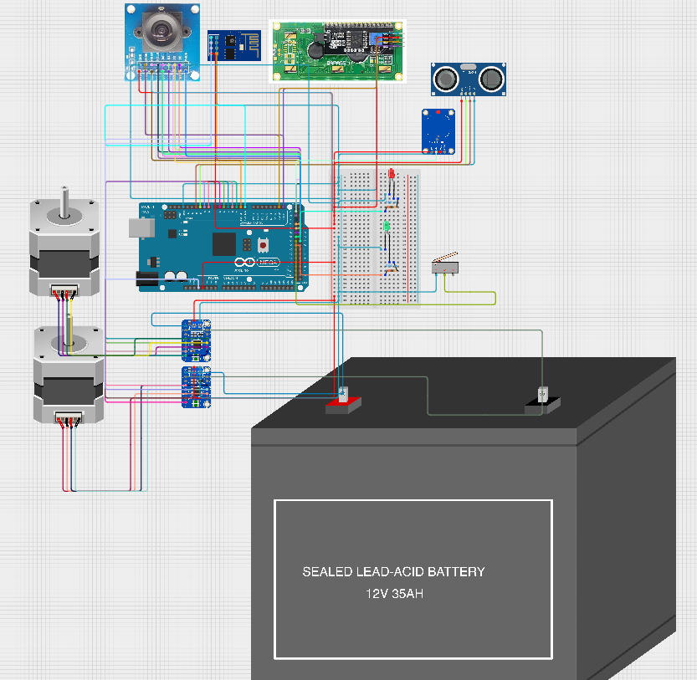

3.1.4 Software and Algorithm

Arduino Mega will be used for this project. Hence, the coding will be using C++ language. The algorithm of the code:
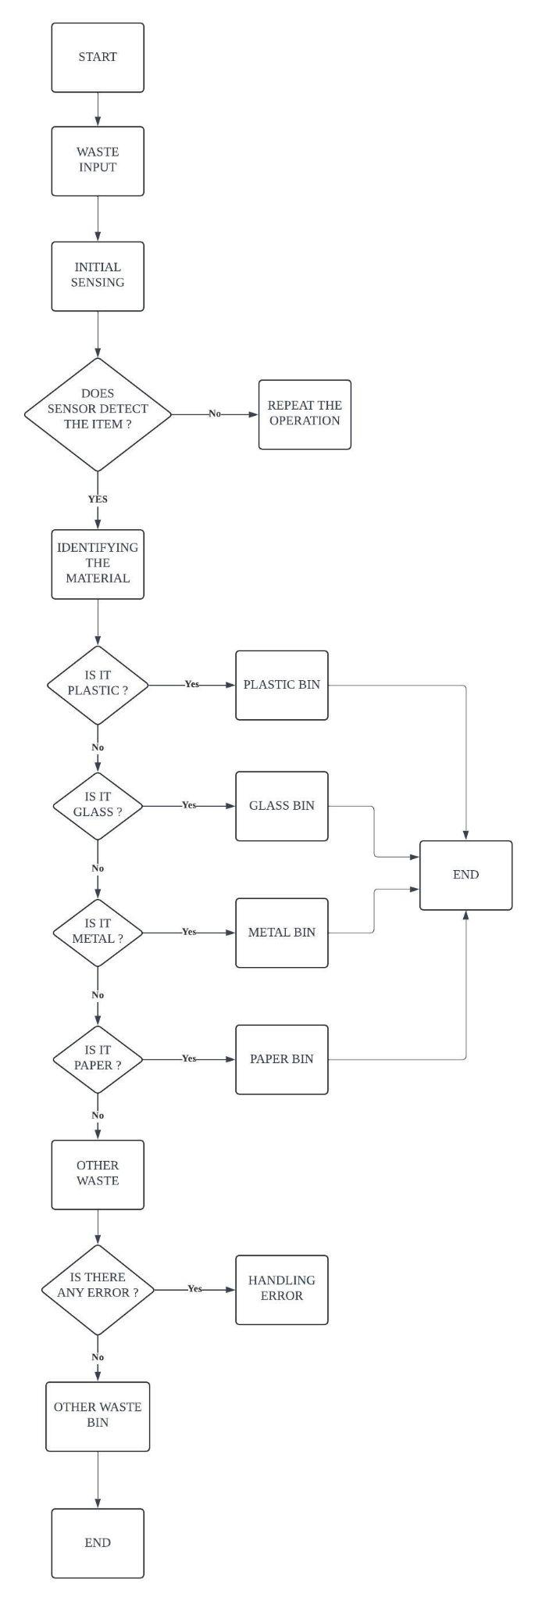

The provided system is written in Python with a GUI. It utilizes Roboflow for model training and classification, along with a serial communication component for potentially interfacing with an Arduino. This is the flow for the code.
Start
- Initialize:
  - Establishes connection to Roboflow API with credentials.
  - Initializes Google Sheets API for data recording.
  - Initializes serial communication (if applicable).
- Manual or Automatic Mode Selection:
  - User chooses between manual and automatic operation mode.
- Manual Mode (if selected):
  - User interacts with buttons corresponding to waste categories (glass, metal, plastic, paper).
  - Sends commands (a, b, c, d) to Arduino (if connected) based on the selected category.
  - Updates spreadsheet with the classified material and timestamp.
- Automatic Mode (if selected):
  - Captures an image from the webcam.
  - Sends the captured image for classification using Roboflow's pre-trained model.
  - Receives the predicted class (glass, metal, plastic, paper) and confidence score.
  - Displays the prediction on the GUI.
  - Updates spreadsheet with the classified material, timestamp, and confidence score.
  - (Potentially) Sends a command to Arduino (if connected) based on the predicted class.
- End
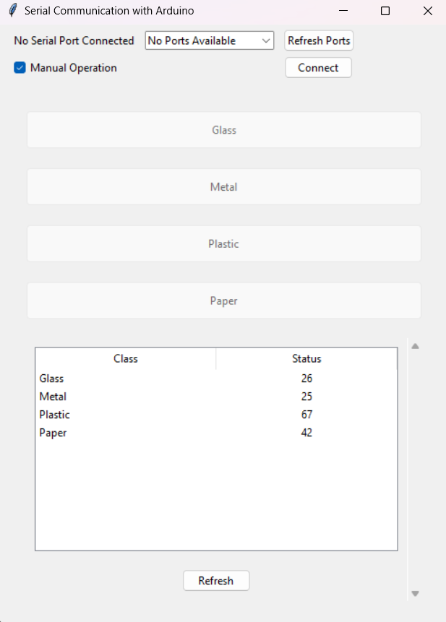 | 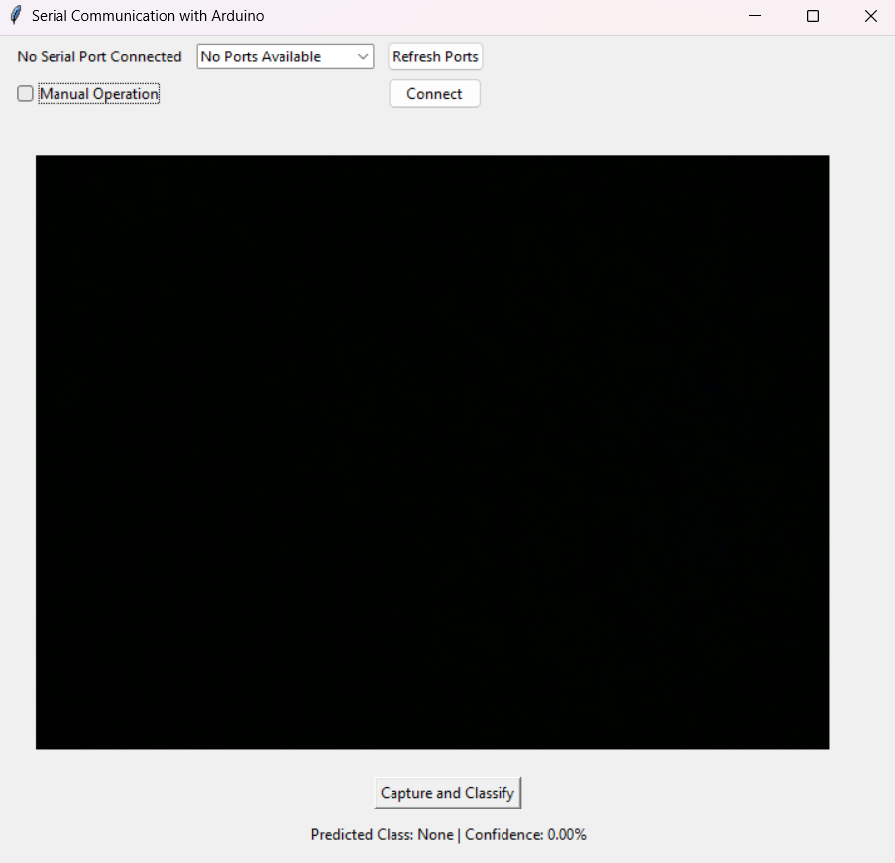
- Manual Mode | - Automatic Mode using Camera

The system operates in two distinct modes: manual and automatic. In manual mode, the user assumes control by selecting the waste material (glass, metal, plastic, or paper) through a designated interface. The system then processes this input, sends a corresponding command to the Arduino (if connected), and records the classification in the Google Sheet. In contrast, the automatic mode leverages machine vision capabilities. The system captures a real-time image of the waste item using a camera, processes it through the Roboflow model for classification, and subsequently sends the predicted class and confidence score to the Arduino (if connected) for appropriate action. This automated approach streamlines the waste segregation process, enhancing efficiency and minimizing human intervention.
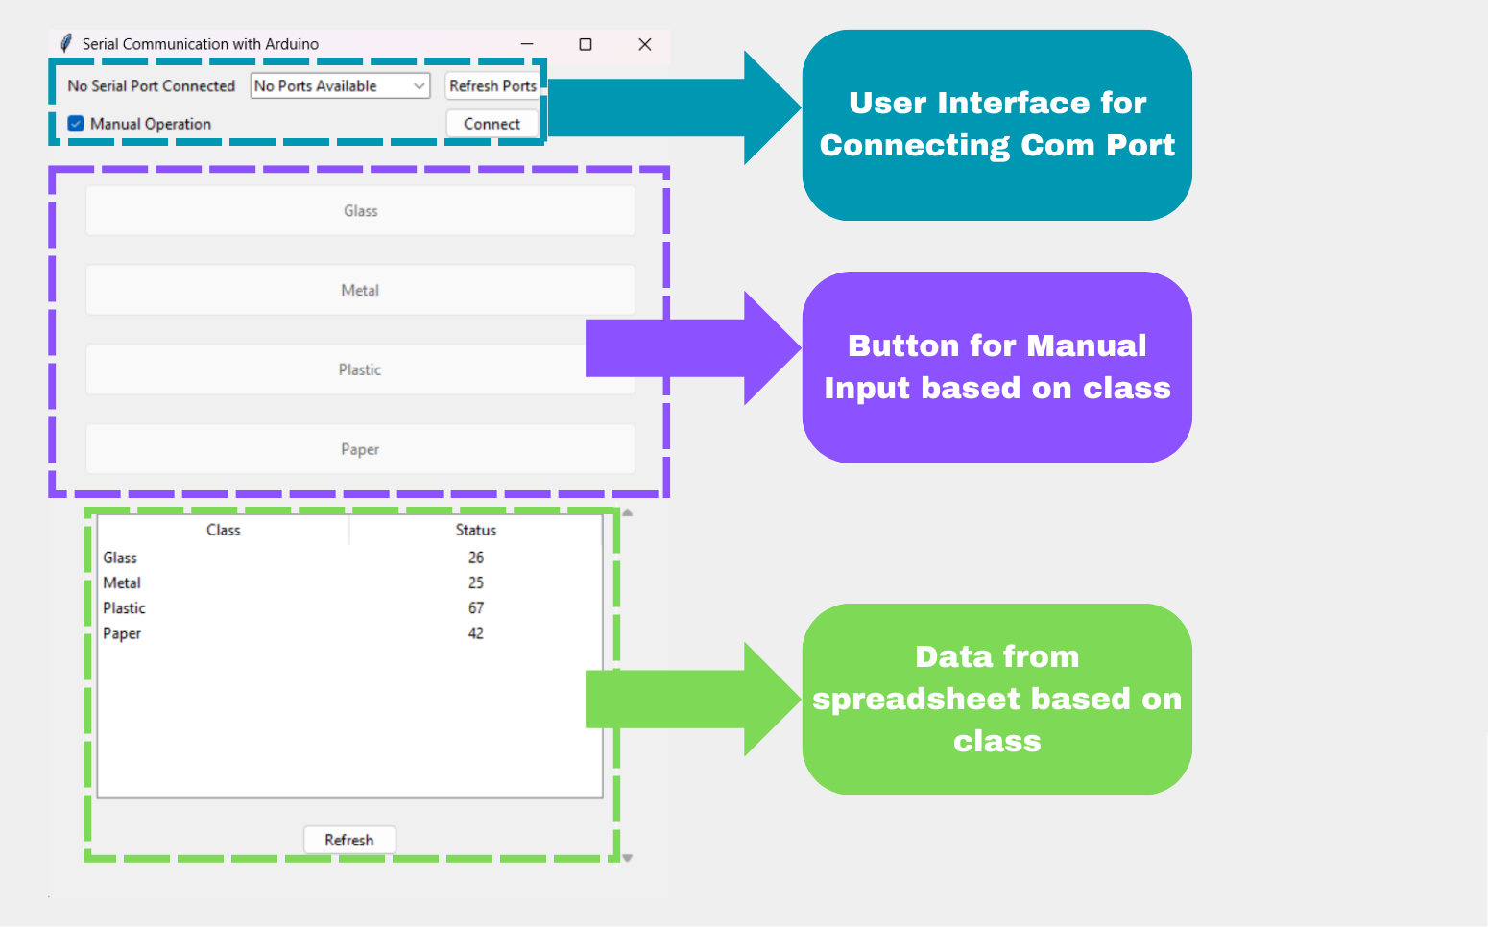
- Features for Manual Mode

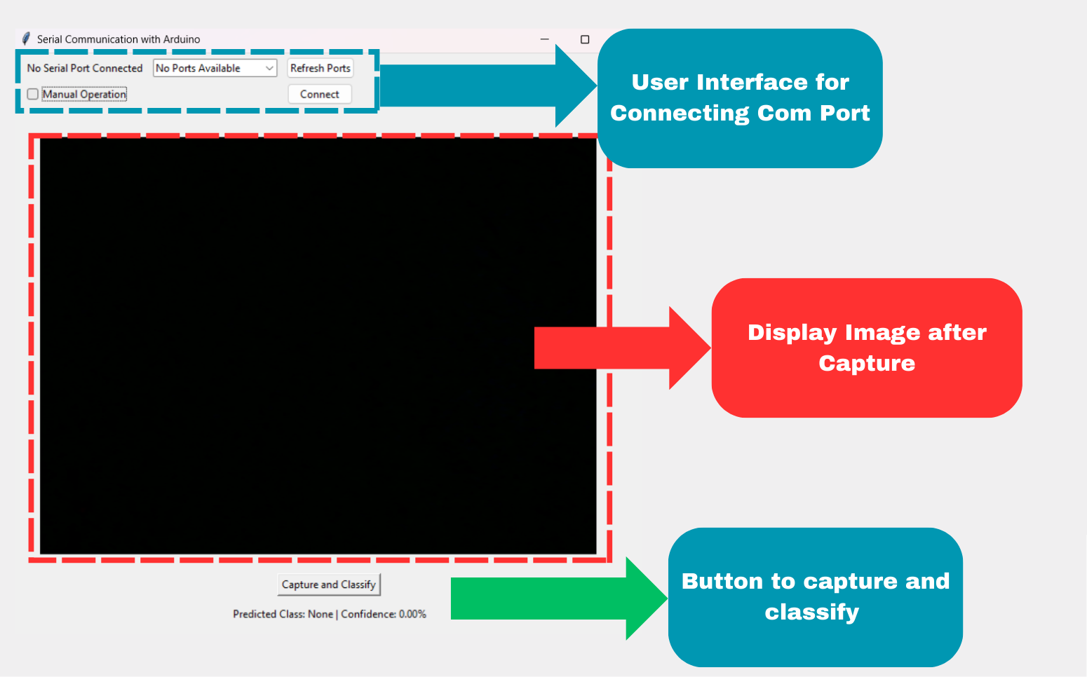
(b) Features for Automatic Mode

3.1.5 Machine Vision using Roboflow
This section delves into the software and algorithmic foundation of the machine vision system. The core of this project utilizes a deep learning approach for image classification, specifically leveraging the Roboflow platform. Roboflow provides a comprehensive suite of tools for streamlining image data preparation, model training, and deployment, making it an ideal choice for this project.
A dataset comprising 120 images was collected, encompassing four distinct waste categories: metal, plastic, glass, and paper. Each category consists of 30 images, providing a balanced dataset for training the model. This dataset was meticulously curated and organized to ensure optimal training performance. The dataset was then split into training, validation, and testing sets, with 70% of the images allocated for training, 15% for validation, and 15% for testing. Subsequently, the collected images were uploaded to the Roboflow platform. The Vit classification model was then selected and employed within the Roboflow environment for training on the prepared training set.
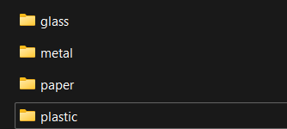 | 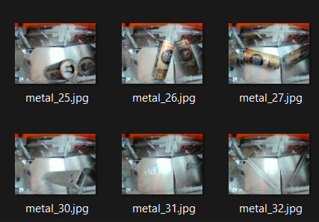
- Folder for Dataset | - Example of Image dataset taken

The Roboflow training metrics show a successful training process. The training loss steadily decreases over the epochs, indicating the model is learning to better classify images. The validation accuracy initially increases rapidly and then plateaus around 0.90, suggesting the model has achieved a high level of accuracy on unseen data. The slight dip in validation accuracy around epoch 35 could be due to overfitting, where the model starts to memorize the training data rather than learning generalizable features. Overall, the model appears to have converged to a good solution, demonstrating its potential for accurate waste classification.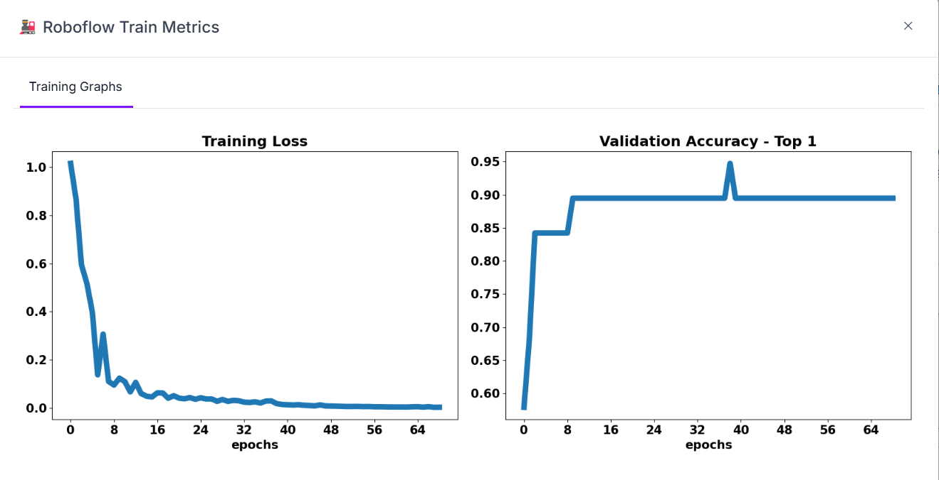
Upon successful model training and validation on the Roboflow platform, the trained model was seamlessly integrated into the project's code through the Roboflow API. This integration facilitated real-time inference, enabling the system to accurately classify new images of waste materials into the designated categories (metal, plastic, glass, and paper). The API provided a convenient and efficient mechanism for deploying the trained model and leveraging its classification capabilities within the broader project context.
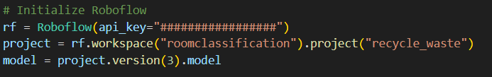
The performance of the trained model was evaluated on a separate test set. The results demonstrate high accuracy in classifying waste materials into the four target categories: metal, plastic, glass, and paper. The model consistently achieved high confidence levels in its predictions, indicating its reliability and effectiveness in real-world scenarios.
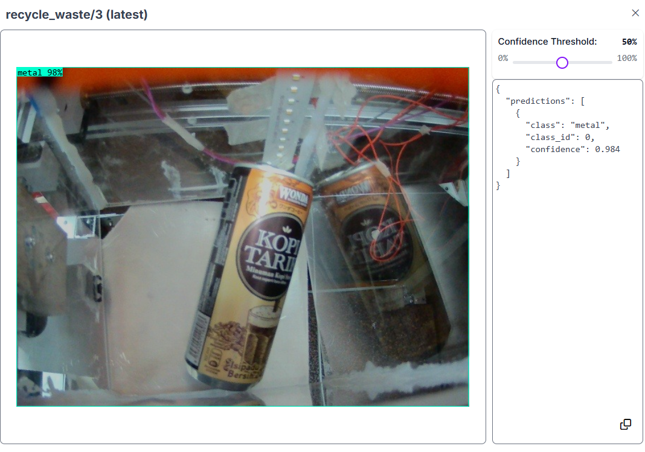
The result with 0.984 confidence of the metal. This provides a concise summary of the model's performance and includes a placeholder for the image and its corresponding prediction with confidence level.

3.2 Component Design
These are the list components for our Automatic Waste Segregation :

NO | COMPONENT | SPECIFICATION
1 | Microcontroller | - Model : Arduino Mega 2560  - Processor : ATmega2560  - Digital I/O Pins : 54 (15 PWM outputs)  - Analog Input Pins : 16  - Operating Voltage : 5V  - Flash Memory : 256 KB  - SRAM : 8 KB
2 | Motor driver | - Model : DRV 8825 Stepper Motor Driver  - Voltage : 8.2V to 45V  - Current : 1.5A per phase (2.2A peak)  - Microstepping : Up to 1/32 step  - Interface : Step and direction control
3 | Bipolar Stepper Motor | - Model : NEMA 17  - Step Angle: 1.8° per step  - Holding Torque: 45 N·cm (63.74 oz·in)  - Current: 1.5A per phase  - Voltage: 12V
4 | Servo Motor | - Model : MG996R  - Operating Voltage: 4.8V - 7.2V  - Stall Torque: 9.4 kg·cm (4.8V), 11 kg·cm (6V)  - Speed: 0.19 sec/60° (4.8V), 0.14 sec/60° (6V)  - Rotation: 180°
5 | Ultrasonic sensor | - Model : HC-SR04  - Operating Voltage: 5V  - Measuring Range: 2cm - 400cm  - Resolution: 0.3cm  - Angle: 15 degrees
6 | Limit switch | - Model : Microswitch  - Operating Voltage: 5V - 250V  - Current: 5A  - Contact Type: SPDT (Single Pole Double Throw)
7 | Led | - Model : 5mm LED  - Operating Voltage: 2V - 3V  - Current: 20mA  - Colours: Red, Green, Blue (RGB option available)
8 | LCD | - Model : 16x2 LCD (HD44780)  - Operating Voltage: 5V  - Interface: Parallel  - Backlight: LED backlight  - Character Size: 5x8 dots
9 | Wire | - Type: Black Red Wire  - Length: 20m  - Gauge: 22 AWG
10 | Frame | - Material : Stainless Steel or Durable Plastic  - 600mm x 600mm x 1000mm ( cuboid shape )  - Thickness : 30mm x 30mm  - The whole main body
11 | Breadboard | - Size: 830 tie-points  - Dimensions: 16.5 x 5.4 x 0.85 cm  - Rows: 2 power rails, 63 rows  - Columns: 10
12 | Camera | - Model : Raspberry Pi Camera Module V2  - Resolution: 8 Megapixels  - Video: 1080p at 30fps  - Interface: CSI connector
13 | Power Adapter | - Input: 100-240V AC, 50/60Hz  - Output: 12V DC, 2A  - Connector: Barrel Jack
14 | Lids | - Material: Stainless Steel or Durable Plastic  - Shape : Square  - Automatic with Touch Sensor
15 | Touch Sensor | - Model: TTP223 Capacitive Touch Sensor Module  - Operating Voltage: 2.0V to 5.5V  - Output: Digital High/Low
16 | Battery Backup | - Model: Li-Ion Rechargeable Battery Pack  - Voltage: 12V  - Capacity: 2000mAh  - Output Current: 1A
17 | Microcontroller shield | - Model : Arduino Mega Shield for stepper motor drivers ( CNC Shield V3)  - Compatible with Arduino Mega 2560  - Designed for easy connection of multiple stepper motor drivers, such as the DRV8825  - Voltage Range: Typically 12-36V DC  - Jumpers to set microstepping resolution (up to 1/32 step with DRV8825)  - Supports up to 4 stepper motors (X, Y, Z, and an additional axis)
18 | CNC Shield V3, DRV8825/A4988 for Arduino | - Model: CNC Shield V3 for Arduino  Compatible with: Arduino UNO and similar boards  - Designed for: Easy connection of multiple stepper motor drivers, such as DRV8825 or A4988  - Voltage Range: Typically 12-36V DC  - Microstepping: Jumpers to set microstepping resolution (up to 1/32 step with DRV8825, up to 1/16 step with A4988)  - Supports: Up to 4 stepper motors (X, Y, Z, and A axes)  Features:  - Integrated GRBL firmware support for CNC applications
19 | Threaded Rod | - Model: M8 Threaded Rod  - Diameter: 8mm  - Length: 500mm  - Thread pitch 2mm (precise) or 8mm (speed)  - Material: Stainless Steel  - Thread Pitch: 1.25mm (standard for M8)  - Tensile Strength: 70,000 to 100,000 psi (depending on material grade)  - Finish: Plain or Zinc-plated for additional corrosion resistance  - Usage: Used in linear motion systems, CNC machines, and load-bearing structures.
20 | Flexible Shaft Coupling | - Model : Aluminum Flexible Shaft Coupling  - Outer Diameter (OD): 19mm  - Length (L): 25mm  - Material: Aluminium Alloy  - Flexibility: Can accommodate slight angular, parallel, and axial misalignments  - Torque Rating: Up to 2 Nm  - Usage: Connects motor shafts to lead screws or other shafts, reduces misalignment stress.

3.2.1 System Drawing
This chapter presents the system design and visual representations of the automated waste segregation system. It showcases the key components and their interconnections, illustrating the flow of data and control signals within the system. The final product is envisioned as a compact and user-friendly unit capable of accurately classifying waste materials and directing them to appropriate receptacles.

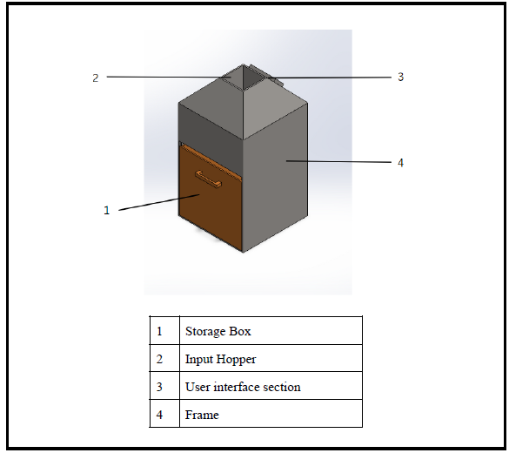
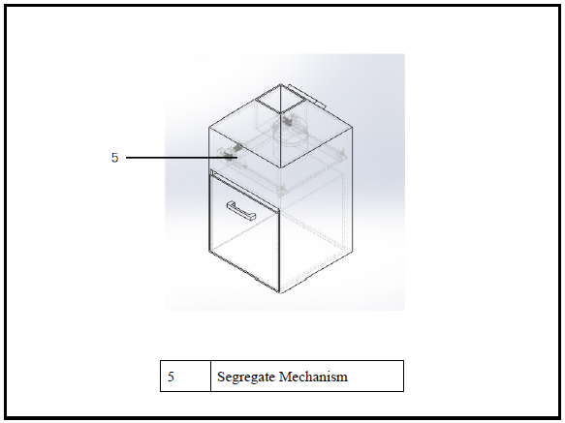
The image showcases the drawing of the automated waste segregation system. Key components visible include the input hopper where waste materials are deposited. The system incorporates a user interface section for interaction and monitoring. The segregated waste materials are then directed to designated storage boxes based on the classification results. The robust frame provides structural support, while the intricate segregate mechanism ensures accurate and efficient separation of different waste types.

- The Frame
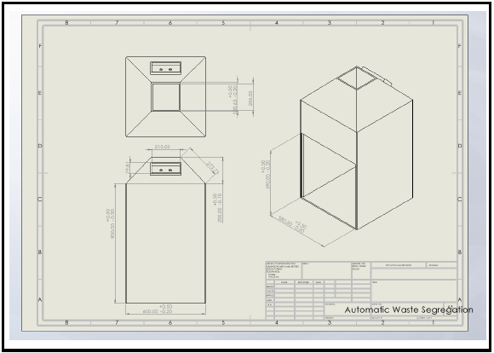
- Storage Box
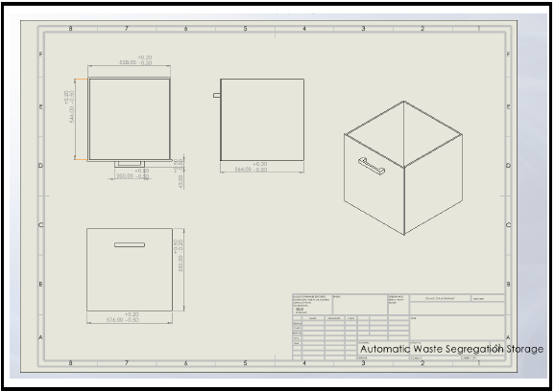
- Stepper motor holder
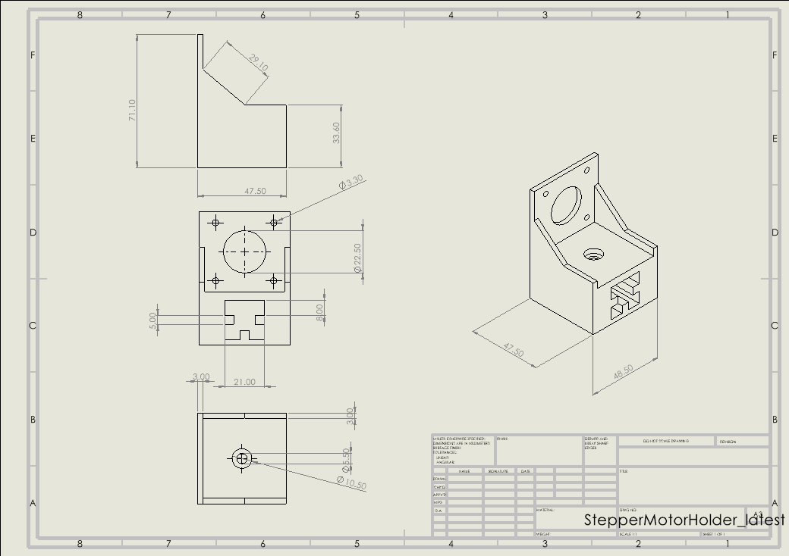
- Connector between x- axis and y-axis for segregate mechanism
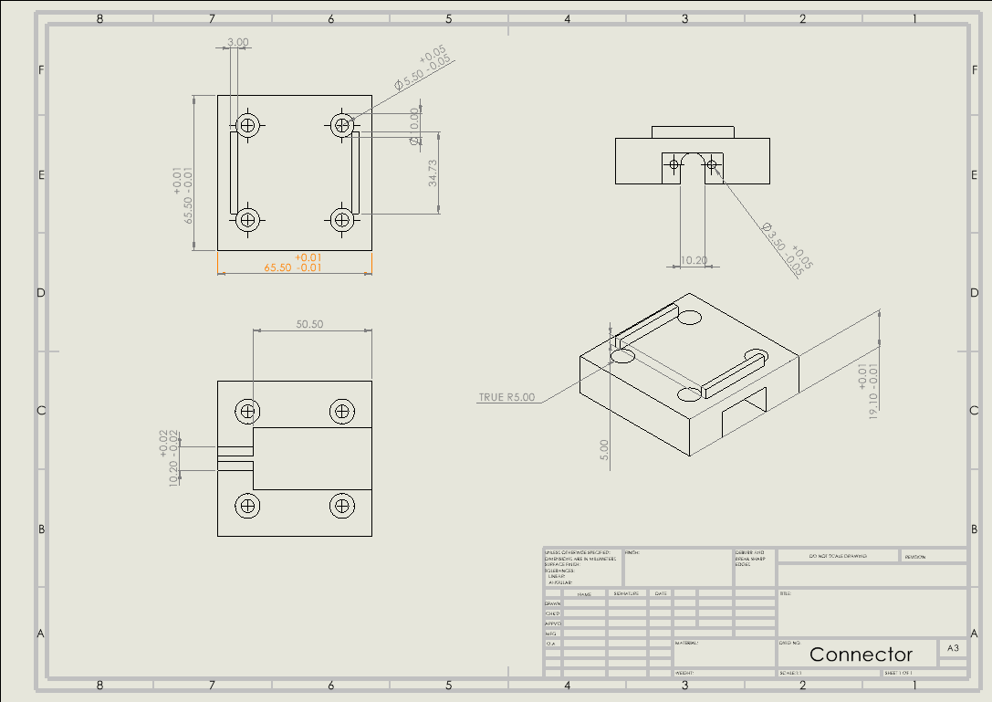

- Bearing holder
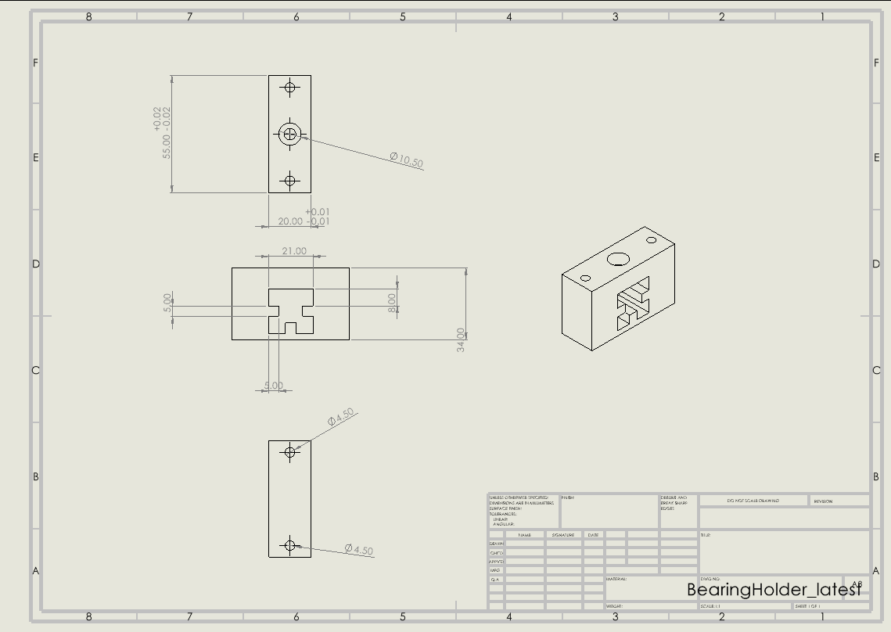

The images provide a visual representation of key components within the automated waste segregation system. The frame serves as the structural foundation, housing all other components and ensuring stability. The storage boxes are designated receptacles for segregated waste materials. The stepper motor holder provides a secure mounting point for the stepper motor, a crucial component of the segregation mechanism. The connector between the x-axis and y-axis facilitates precise movement within the segregation mechanism, located in Area B as per the conceptual design. Lastly, the bearing holder supports the smooth and efficient operation of the segregation mechanism by minimizing friction and wear and tear.

This is the result of the mechanical for the area B :

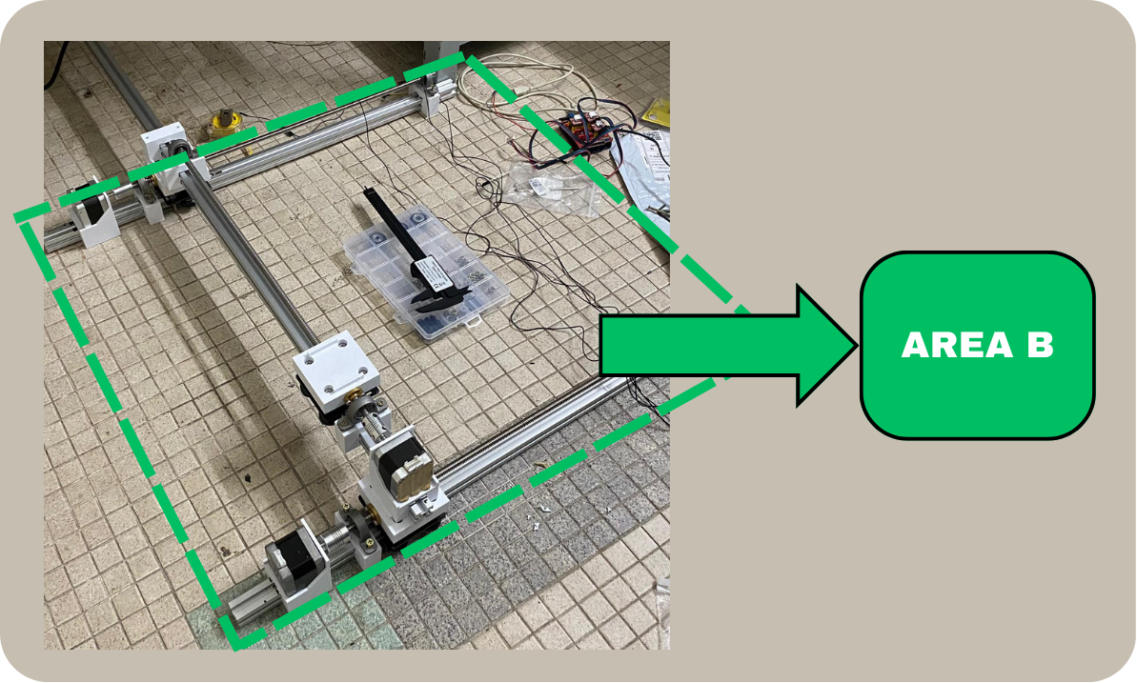
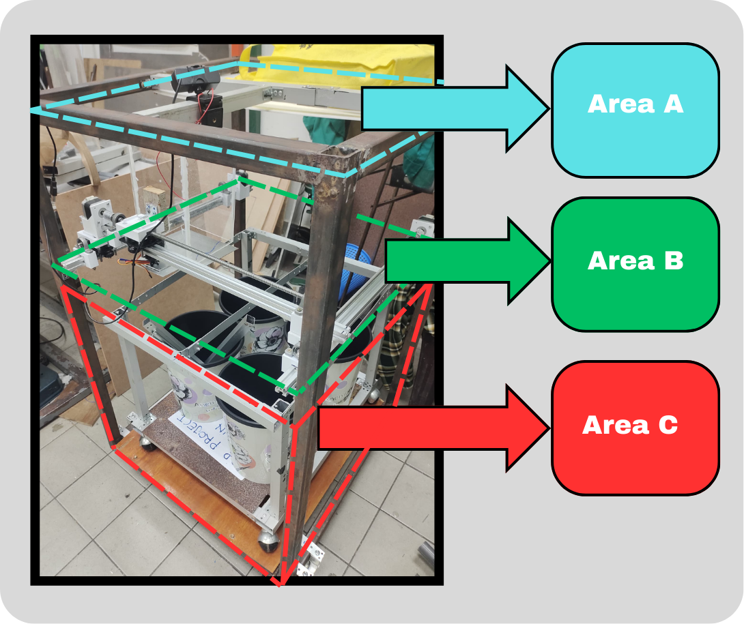
The images depict the prototype of Areas A, B, and C within the automated waste segregation system. Area A serves as the input zone, where waste materials are initially deposited. Area B houses the core segregation mechanism, incorporating components such as the stepper motor holder, connector between the x-axis and y-axis, and bearing holders to facilitate precise and controlled movement for sorting. Area C represents the output zone, where segregated waste materials are directed to designated storage containers.
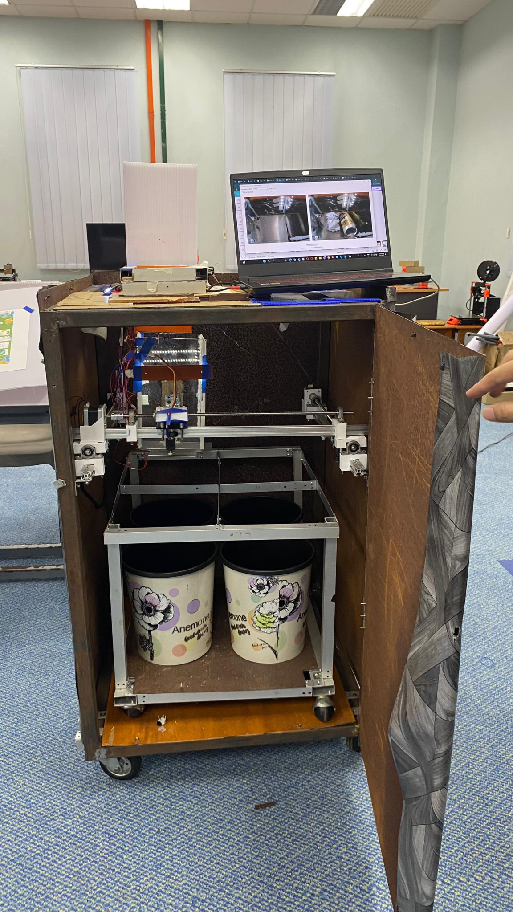 | 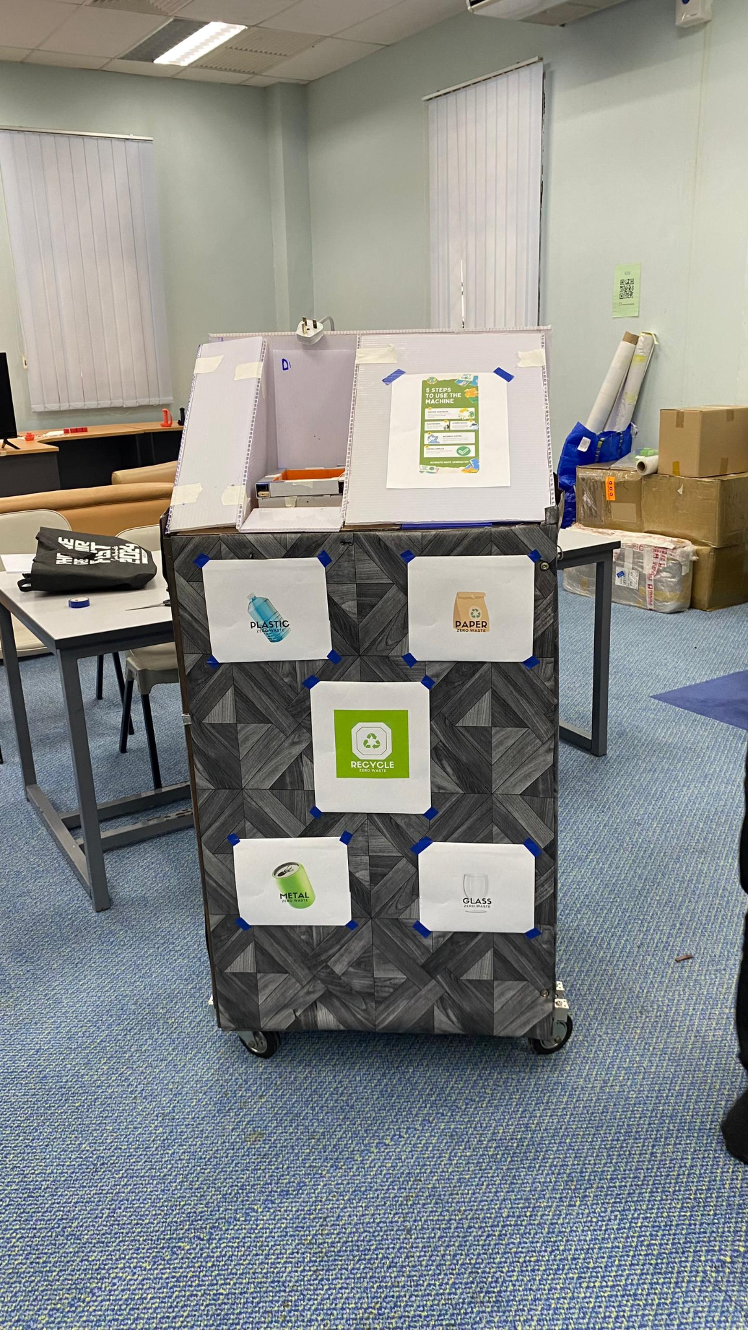
- Automated Waste Segregation System: Interior View with Door Open | - Automated Waste Segregation System - Final Prototype

The images show the completed system and its internal components, including the input hopper, storage bins, and the mechanism for sorting waste. A video demonstration of the system in action can be found here .mp4 file :
https://github.com/zarady/Automatic-Waste-Segregation.
This system has the potential to improve waste management by efficiently and accurately sorting different types of waste.

3.3 Design of Manufacture ( DFM )
Design for Manufacture (DFM) is an engineering method dedicated to crafting products that enhance the manufacturing process. The aim of DFM is to boost efficiency, reduce production costs, and elevate the quality of the final product.
In our automatic waste segregation project, it has been mandatory to follow the Design for Manufacture (DFM) approach to achieve maximum efficiency for the design and cost implementation of the system. It was possible to move from the use of cumbersome and expensive materials to more economical types without having to lose the effectiveness of the products. For example Storage Box is made of the high plastic material, which was chosen for the fact that it is rather durable and has a good form for molding, which will reduce the cost of manufacturing and production. Thus, the Segregate Mechanism uses standardized constituents to simplify the assembly process and reduce the amount of unique constituents needed. This product is a Stepper Motor Holder made of wooden material; the choice is mainly due to the affordable price and ease of processing, which helps to keep the price low and environmentally friendly. Last but not the least, the Cylinder Holder made out of sturdy steel aims at strength and precision manufacture hence assuming the responsibility of holding the mechanism firmly in operation. These choices and the modifications made to the design guarantee that each component is not only simple and cost-effective to manufacture but also meets our mission to design a dependable waste sorting system. Also, tight tolerances are required when it comes to Segregate Mechanism and Cylinder Holder to guarantee flawless interlocking and eliminate possible misalignments which could negatively impact operations or wear down components. Maintaining both parsimony and efficiency, our DFM approach allows us to propose a solution of the maximal quality and adaptability to various segregation requirements while not going over budget.

3.4 Design of Assembly ( DFA )
Design for Assembly (DFA) is an engineering strategy aimed at simplifying the assembly process of products. The core objective of DFA is to streamline the assembly by reducing the number of parts involved, making the components easier to put together, and enhancing overall manufacturing efficiency.
In our project focused on automatic waste segregation, we applied Design for Assembly (DFA) principles to enhance the efficiency and user-friendliness of the system. We designed each component—the Storage Box, Segregation Mechanism, Stepper Motor, Stepper Motor Holder, and Cylinder Holder (Segregation Mechanism)—with simplicity and ease of assembly in mind. The Storage Box is crafted for straightforward integration with the other components, ensuring quick and seamless assembly. The Segregation Mechanism is modular, allowing for independent assembly and easy maintenance or replacement. To further streamline the process, the Stepper Motor Platform and its Holder are designed to fit together effortlessly, minimizing the need for complex adjustments or specialized tools. The Cylinder Holder, essential for the Segregation Mechanism, is precisely engineered to ensure a snug fit, reducing potential alignment issues and ensuring reliable operation. By carefully selecting materials and designing tolerances for critical areas, we ensured that the assembly process is smooth and efficient. This approach not only simplifies the build and setup of the system but also enhances the overall reliability and performance of our automatic waste segregation solution.

3.5 Costing
No | Item | Shop | Quantity | Cost (RM)
1 | Arduino Mega 2560 | Shoppee | 1 | RM 55.90
2 | T8 lead screw D8mm | Shoppee | 3 | RM 75.00
3 | DRV8825 DC CNC Stepper Motor Driver | Shoppee | 3 | RM15.84
4 | Bipolar Stepper Motor NEMA 17 | Shoppee | 2 | RM 80.70
5 | KP KFL Block Ball Bearing | Shoppee | 6 | RM 29.28
6 | Servo Motor MG996R | Shoppee | 1 | RM 11.92
7 | Ultrasonic sensor HC-SR04 | Shoppee | 4 | RM 2.85
8 | Limit switch | Shoppee | 1 | RM 1.20
9 | 5mm LED | Shoppee | 2 | RM 0.79
10 | LCD 16x2 (HD44780) | Shoppee | 1 | RM 11.88
11 | Wire | Shoppee | 1 | RM 9.80
13 | Square Hollow Stainless Steel | Shoppee | 1 | RM 92
13 | Breadboard | Shoppee | 1 | RM 5.67
14 | V-Aluminium(1meter x 3 units) | shoppee | 1 | RM 190
15 | Power Adapter ( barrel jack ) | Shoppee | 1 | RM 13.80
16 | TTP223 Capacitive Touch Sensor Module | Shoppee | 1 | RM 0.77
17 | Li-Ion Rechargeable Battery Pack | Shoppee | 1 | RM 15.20
18 | Arduino mega Shield - CNC Shield V3 | Shoppee | 1 | RM 20.90
19 | Threaded Rod | Shoppee | 3 | RM 25.42
20 | Aluminum shaft coupling | Shoppee | 3 | RM 16.83
21 | 3d printer estimation | Shoppee | 1 | RM 10
22 | Set v-aluminium-wheel(10x24mm) | Shoppee | 3 | RM 71.7
23 | Tools/ Screw/ Nut | Shoppee | 1 | RM 50
Total costs |  |  |  | RM 807.45

3.6 Discussion on Safety, Environment, Social Impact and Sustainability Product

When proposing an Automatic Waste Segregation System (AWSS), it is crucial to think about Safety, Environment and Societal Implications since the three elements are among the most important criteria governing the efficiency, sustainability and beneficial effects of the proposed system in society.
3.6.1 Safety
Security is very important and has been incorporated into the AWSS design to enable it to operate efficiently while protecting its users. Safety remains one of the most important aspects in designing and therefore we have several aspects that are put in place in this aspect. First, an emergency shut off mechanism is to be incorporated where it can be accessed through the physical main switch on the machines. This emergency switch is a decided advantage as it immediately shuts down the entire power governing the system in case of any incident. Moreover, we provide the system alarm in the form of light (LED) alerts and sound (buzzer) to compel users to stop using the equipment to prevent possible dangers to the user and the machine. These safety measures further correlate with our AMBITION to use in a safe AWSS that provides safety to its users whilst upholding functionality always.
3.6.2 Environment
Environmental issues therefore come into play as AWSS plans on minimizing landfill waste in addition to advocating for recycling. This means that through grouping recyclable materials well to allow easy practice of recycling, the system assists in sustaining resources and cutting down impacts of waste disposal on the environment. Some of the developments including energy efficiency and new energy sources reduce the emission of carbon and help upgrade the waste disposal practices. This can be a specific air or water quality that measures indicate that waste segregation activities are not affecting the environment adversely.
3.6.3 Social Impact
Community Health, Resources, and social issues are the last aspects that are affected by AWSS in the lives of people across the societies. In a way that boosts the quality environment and fights pollution, AWSS reduces various health hazards and effects associated with improper disposal of wastes in the communities. Optimization in waste processing processes contributes to the enhancement of resource recycling practices bringing minimal impacts on the extraction of raw materials. In the same way, that will generate employment chances where some of them are in waste management and recycling industries where it will help the economy and also assist in achieving equal chances of accessing the services by all the people regardless of their status.
3.6.4 Sustainability
In this study, the sustainability of AWSS is measured by the ability of the system to optimally use resources within its production process, and the least environmental degradation within its lifespan with reference to sustainability. This entails choosing long-lasting, sustainable and non-hazardous materials into the to be developed facility, incorporating green energy systems like photovoltaic system and regular practice of source reduction on wastes through segregation and recycling. Doing Life Cycle Assessments (LCAs) before an item is manufactured and produced, reduces its effect on the environment when it is being manufactured, used, and even disposed of. Thus, it is important for AWSS to follow environmental measures and utilise resources in such a way as to cause less or no harm to the environment, due care and maintenance for the equipment and following sustainable waste disposal techniques.
Consequently, factors such as safety, sustainability, environment and social effect should be included into the AWSS in order to safeguard operational safety, environmental friendliness as well as inculcate the positive impacts of safety on the society such as improved quality of life due to less incidences of injuries, preservation of natural resources as well as provision of jobs. These aspects in unison strengthen the system as well as its impact on the overall benefits to local communities, and larger environmental concerns.

CHAPTER 4: MARKETING AND BUSINESS MODEL

4.1 Scaling Up and Marketing the Product
To effectively scale up and market the Automatic Waste Segregation System (AWSS), the following strategies will be adopted:

4.1.1 Target Market Segmentation
- Primary Audience: We want to sell this product to towns small towns residential properties and national waste treatment facilities.
- Secondary Audience: Our product serves schools, industries, and office buildings.

4.1.2 Marketing Strategies
- Awareness Campaigns: The product will gain exposure by presenting its functions through social media platforms while holding live demonstrations and attending waste management events.
- Strategic Partnerships: Partner with waste management providers and environmental groups to help our business reach more customers.
- Customer Education: Host educational programs to explain to users how automated waste sorting systems benefit our planet.

4.1.3 Distribution Channels\
- Direct sales to institutions and organizations.
- Our sales strategy includes direct distribution and web platforms that offer standard and custom solutions to customers.
- We connect our services to waste management and recycling businesses across multiple markets through distribution alliances.

4.1.4 Future Expansion
- Aiming to offer our solution in many different countries where waste handling needs improvement.
- The AWSS can benefit from IoT and AI additions in modular features that provide ongoing system oversight and data performance tracking.

4.2 Break-Even Analysis
Break-even analysis helps find the exact sales level where expenses match revenue and profitability becomes zero.
4.2.1 Fixed Costs
- Research and development: RM 50,000
- Manufacturing setup: RM 30,000
- Marketing and distribution: RM 20,000
4.2.2 Variable Costs (per unit):
- Production cost: RM 807.45 (including components and assembly).
- Distribution and packaging: RM 50.
4.2.2 Selling Price
The estimated selling price stands at RM 1000 per unit due to market demand and competitor pricing levels.

4.2.3 Break-Even Point Calculation
Using the formula:

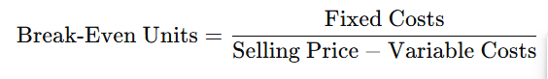

Break-Even Units = (50.000 + 30.000 + 20.000) / (1.000 -807.45) ≈ 520 units.
With a variable cost of RM 807.45, the company must sell approximately 520 units to break even.

4.3 Summary
The AWSS delivers innovative waste solutions by using automated technology to benefit both waste control and the environment. Our successful growth strategy combines market analysis with business connections plus price optimization to reach more customers. The business model shows clear profitability potential because reaching 227 units in sales breaks even with costs while smart marketing drives success.

CHAPTER 5 : CONCLUSION
This project successfully demonstrates the feasibility of developing an automated waste segregation system. The system utilizes a combination of image recognition technology, powered by Roboflow, and a robust mechanical design to accurately classify and sort waste materials. By automating this process, the system offers significant potential for improving waste management practices in various settings, from residential complexes to commercial establishments. By reducing manual sorting efforts, the system contributes to increased efficiency and reduced labor costs, making waste management more sustainable and economically viable. The compact and user-friendly design of the system ensures ease of operation and integration into existing waste disposal infrastructure. Furthermore, the successful implementation of this project provides valuable insights into the application of machine learning and robotics in environmental sustainability. This project serves as a foundation for future iterations and advancements in automated waste management solutions, paving the way for a cleaner and more sustainable future.
The successful development of this automated waste segregation system highlights the potential for innovative solutions to address environmental challenges. By combining cutting-edge technology with a user-centered design approach, the system demonstrates a practical application of sustainable principles. The project's findings can be further explored in various contexts, such as integrating the system into smart cities or developing customized solutions for specific waste streams. Continued research and development in this area will be crucial for advancing waste management practices and promoting a circular economy. This project serves as a valuable proof-of-concept, inspiring future endeavors in sustainable technology and environmental stewardship.

